**Planning, Designing and Establishing an Improved Network for Telus International Philippines Inc. through Network Simulation Facilities**

**A Network Project Proposal**

**Presented to the Faculty of Information and Communication Technology Program**

**STI College Global City**

**In Partial Fulfillment for the requirement in the degree**

**Bachelor of Science in Information Technology**

**Submitted by:**

Andrade, Cherry

Enriquez, Eugene

Felix, Patrick Leon

Gamotin, John Cedric

Perez, John Eduard

Sambajon, Allyson Anne

**A601**

**Submitted to:**

Mr. Dave John Ravina

**2021**

**Table of Contents**

**1.1 Company Profile**

**1.2 Statement of the Problem**

**1.3 Objectives**

**1.4 Logical Configuration of the proposed network**

**1.5 Recommendations and Summary**

**1.6 Curriculum Vitae**

**Abstract of the Network Project Proposal**

* 1. **Company Profile**

**Company Name:** Telus Market Market!

**Location:** 5/F Market! Market! Mall, Bonifacio Global City, Taguig City 1634, Philippines

**IT Department**

• Automation Tester

• Security Operations Center Analyst

• Cyber Security Analyst

• Salesforce Developer

• Technology Analyst

• Oracle Database Administrator

• DevOps Engineer (Google Cloud)

• Java Developer

• Software Engineer In Test (SDET)

• QA for Developers

• Software Quality Assurance

• Cloud Support

**HR Department**

• QA for Developers (Shifting Schedule)

• Performance Tester

**Accounting Department**

• Accounts Senior Payable Analyst

• Workday Senior ERP Analyst

• Senior Financial Analyst

**Sales Department**

• Sales Representative

• Customer Service Representative

• Telephone Sales Representative

**TELUS Digital Principles**

**Focus on Customer First**

Customers expect to be able to do what they want in a way that fits their life. We think like our customers, anticipating their needs and crafting seamless, personalized experiences that span physical and digital customer journeys.

**Value data over opinions**

The best decisions are those that are informed by the customer and team member feedback. We build products with results we can measure, informing our decisions with data rather than just listening to the loudest voice in the room.

**Deliver outcomes over outputs**

Customers and team members want products that simplify their lives over those filled with unnecessary features. We prioritize building experiences that deliver tangible results for our customers and teams over feature development.

**Take risks and be lean**

Our customers’ needs change quickly and can be difficult to predict. We embrace ambiguity with agility by experimenting, taking calculated risks and celebrating failures to pivot quickly and continuously improve.

**Build for quality and reuse**

Customers want high-quality experiences delivered quickly without errors and complexity. We showcase our work, reuse solutions, leverage shared platforms, and automate development practices to meet our leading customer experience standards.

**Be an owner**

Owners are curious, create long-term value, and constantly challenge the status quo. We collaborate beyond our individual functions and lines of business, pursue high-value ideas in our teams, and individually and respectfully assert ourselves when we disagree.

**Attract and develop leaders**

Leaders tackle the most ambiguous and complex challenges while helping our team scale. We constantly raise the talent bar by seeking out exceptional, passionate people and providing them with development opportunities that enable them to choose their own career paths.

**Embrace inclusivity**

Diversity breeds new ideas, innovation, and a better working environment. We respect and empathize with each other, fostering an inclusive culture where everyone can express their ideas and be their authentic self.

**Strengthen communities.**

Creating shared value in our communities benefits TELUS and Canada. We invest in our team members so that they can drive positive social impact in the areas of health, education, environment, and digital literacy.

* 1. **Problems**

**STATEMENT OF THE PROBLEM**

They are expecting the Internal Support Team to develop the network infrastructure plan. This will include, but is not limited to:

1. Recommendations on network equipment
   * Switch
   * Wireless Router
   * Router
   * Server PC
   * Laptop
   * PC (Monitor, System unit, Keyboard, and Mouse)
   * Cat6 cable
   * UPS server
2. Recommendations on network cabling

The team will be using Cat 6 since it is a more reliable cable at higher speeds than Cat 5 or Cat 5e. They look almost the same. In fact, Cat 6 is backward compatible with Cat 4, so you can mix and match. CAT6 cable provides better bandwidth than CAT5e, and the rated frequency is up to 250 MHz, while CAT5e is 100 MHz, which means that more data can be processed at the same time. Compared with CAT5e, 250 MHz to 10 Gigabit Ethernet can run at 100 MHz, and it supports up to 1 Gigabit Ethernet.

1. A network wiring plan including:
2. Physical and Logical cabling layout

**Physical Layout**

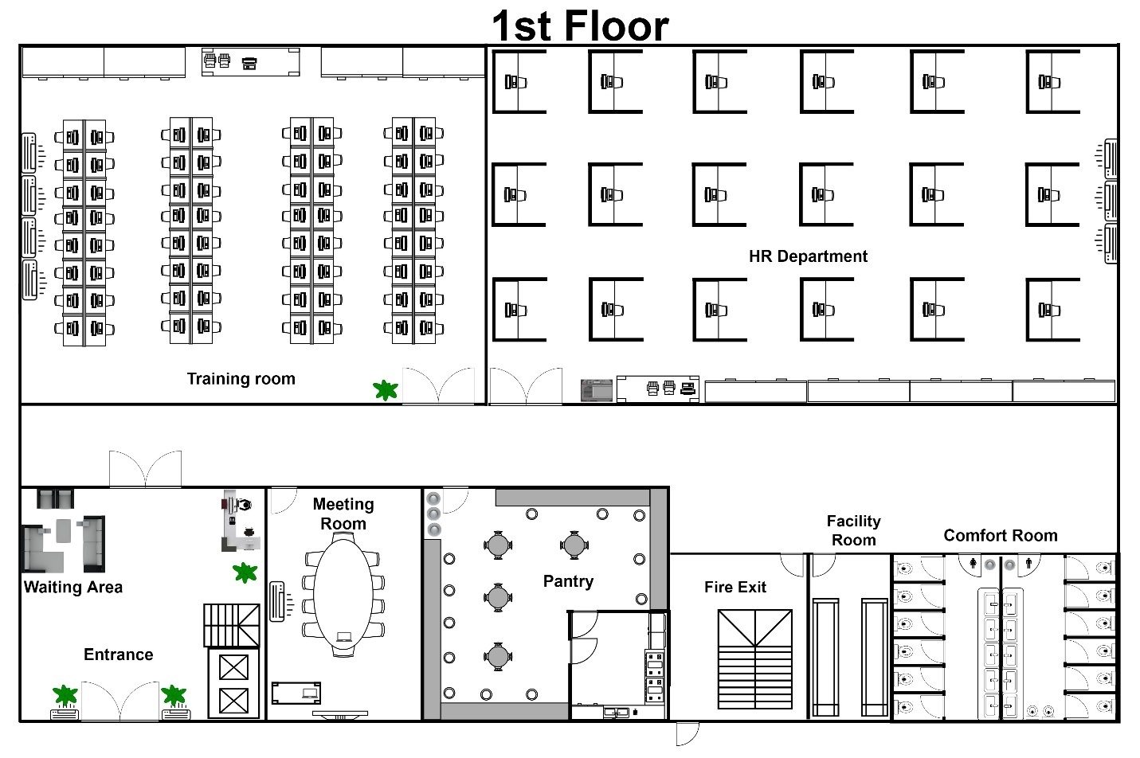

**1st Floor**

**Legend**

|  |  |  |
| --- | --- | --- |
| Elevator | Stairs | Office Table |
| Office Table/ Workstation | Toilet Bowl | Television |
| Plant | Laptop | Chair |
| Dresser | Large office table | Sofa |
| Door | Double Door | Table |
| Cabinet | Air Conditioner | Sink |
| Printer | Xerox Machine |

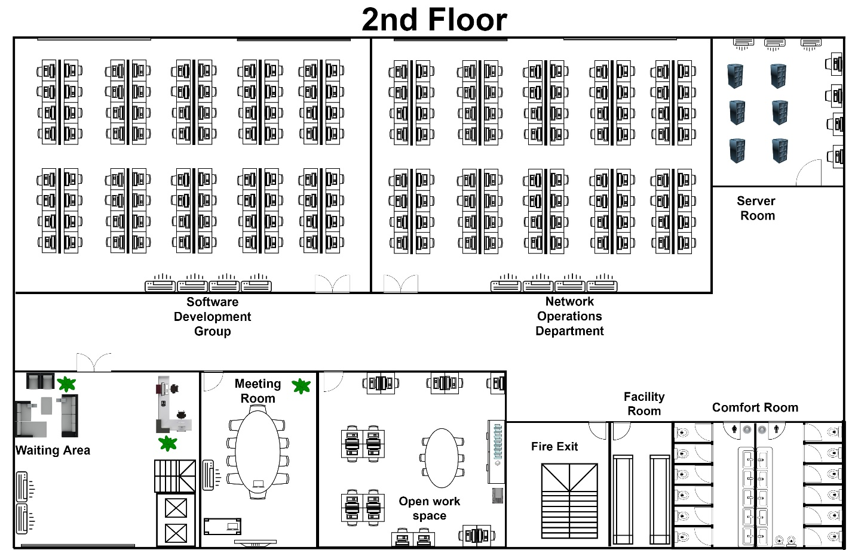

**2nd Floor**

**Legend**

|  |  |  |
| --- | --- | --- |
| Elevator | Stairs | Office Table |
| Office Table/ Workstation | Toilet Bowl | Television |
| Plant | Laptop | Chair |
| Dresser | Large office table | Sofa |
| Door | Double Door | Table |
| Cabinet | Air Conditioner | Sink |
| Printer | Xerox Machine | Books |
| Server Rack |

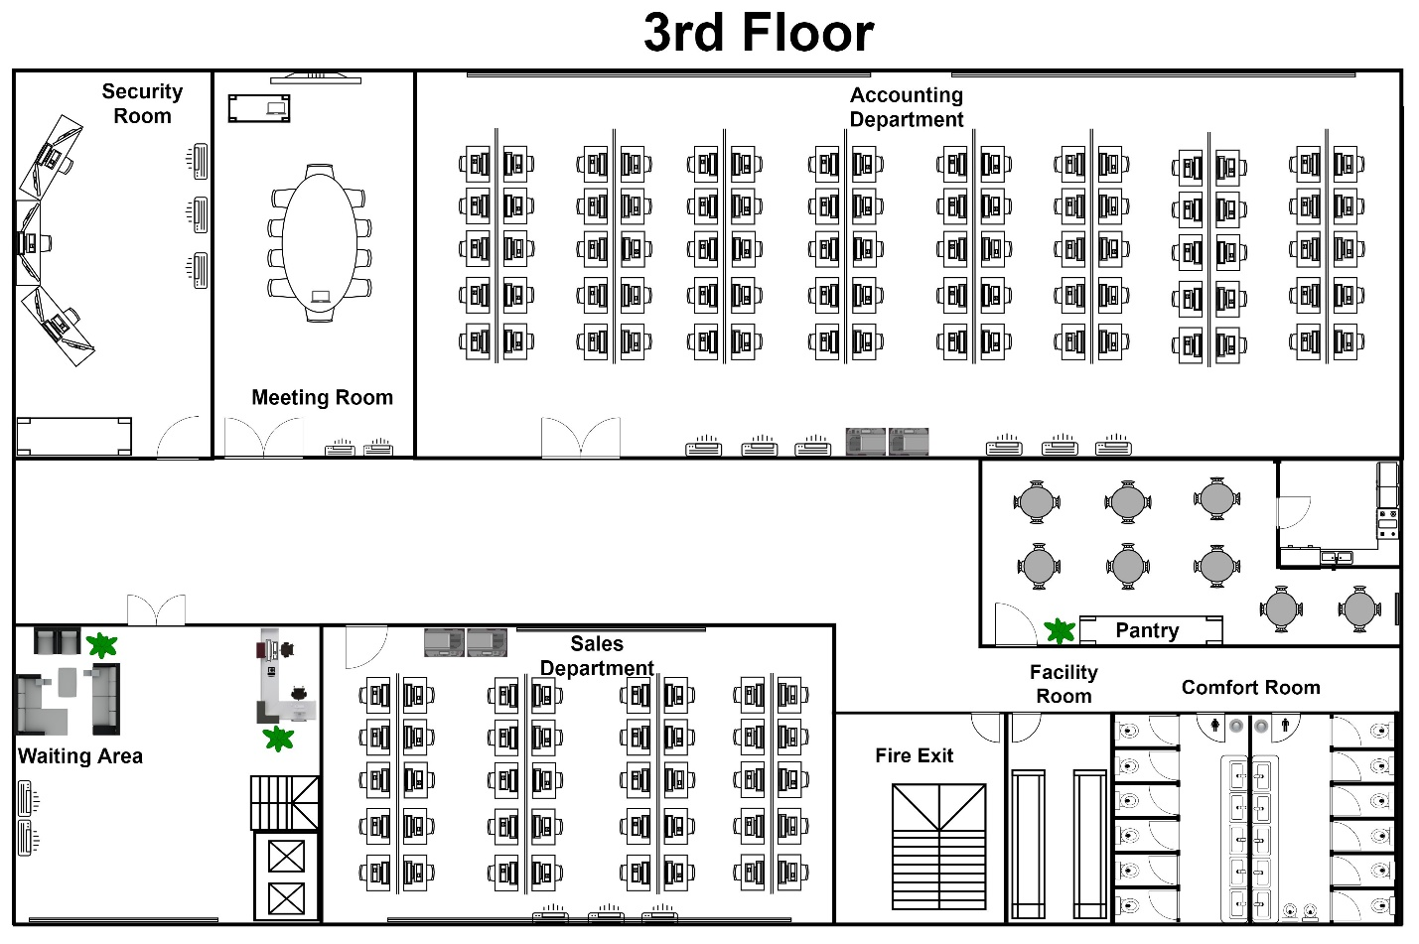

**3rd Floor**

**Legend**

|  |  |  |
| --- | --- | --- |
| Elevator | Stairs | Office Table |
| Office Table/ Workstation | Toilet Bowl | Television |
| Plant | Laptop | Chair |
| Dresser | Large office table | Sofa |
| Door | Double Door | Table |
| Cabinet | Air Conditioner | Sink |
| Printer | Xerox Machine |

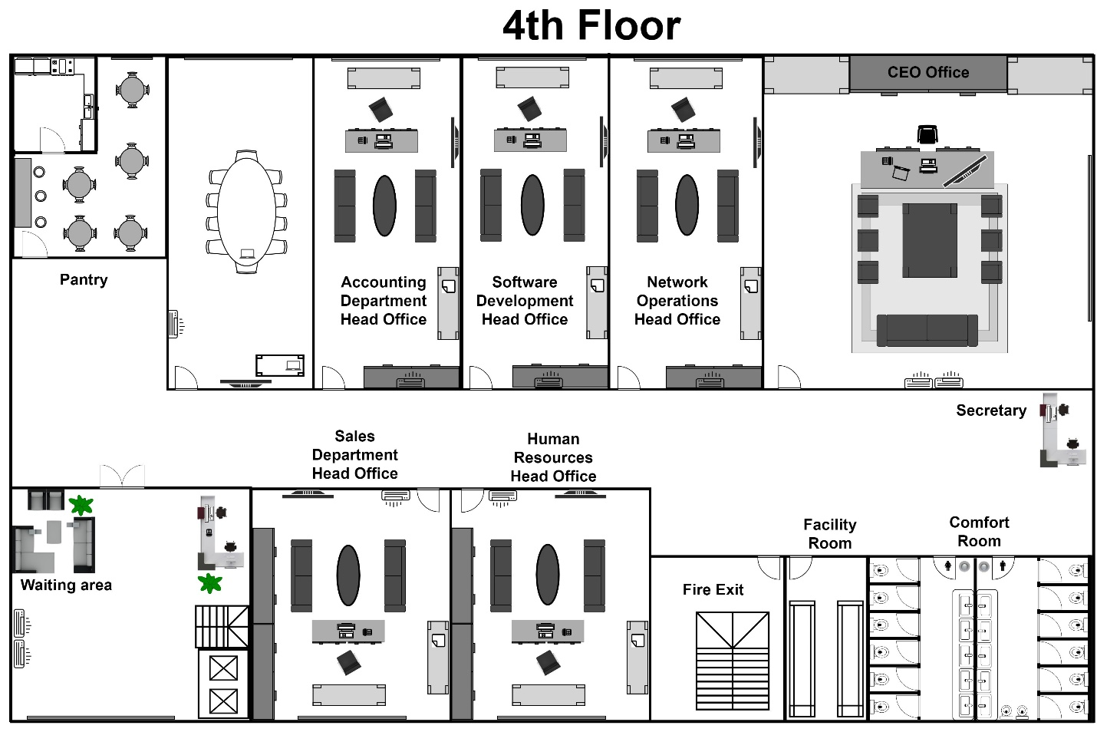

**4th Floor**

**Legend**

|  |  |  |
| --- | --- | --- |
| Elevator | Stairs | Office Table |
| Office Table/ Workstation | Toilet Bowl | Television |
| Plant | Laptop | Chair |
| Dresser | Large office table | Sofa |
| Door | Double Door | Table |
| Cabinet | Air Conditioner | Sink |
| Printer | Xerox Machine |

**Logical Cabling Layout**

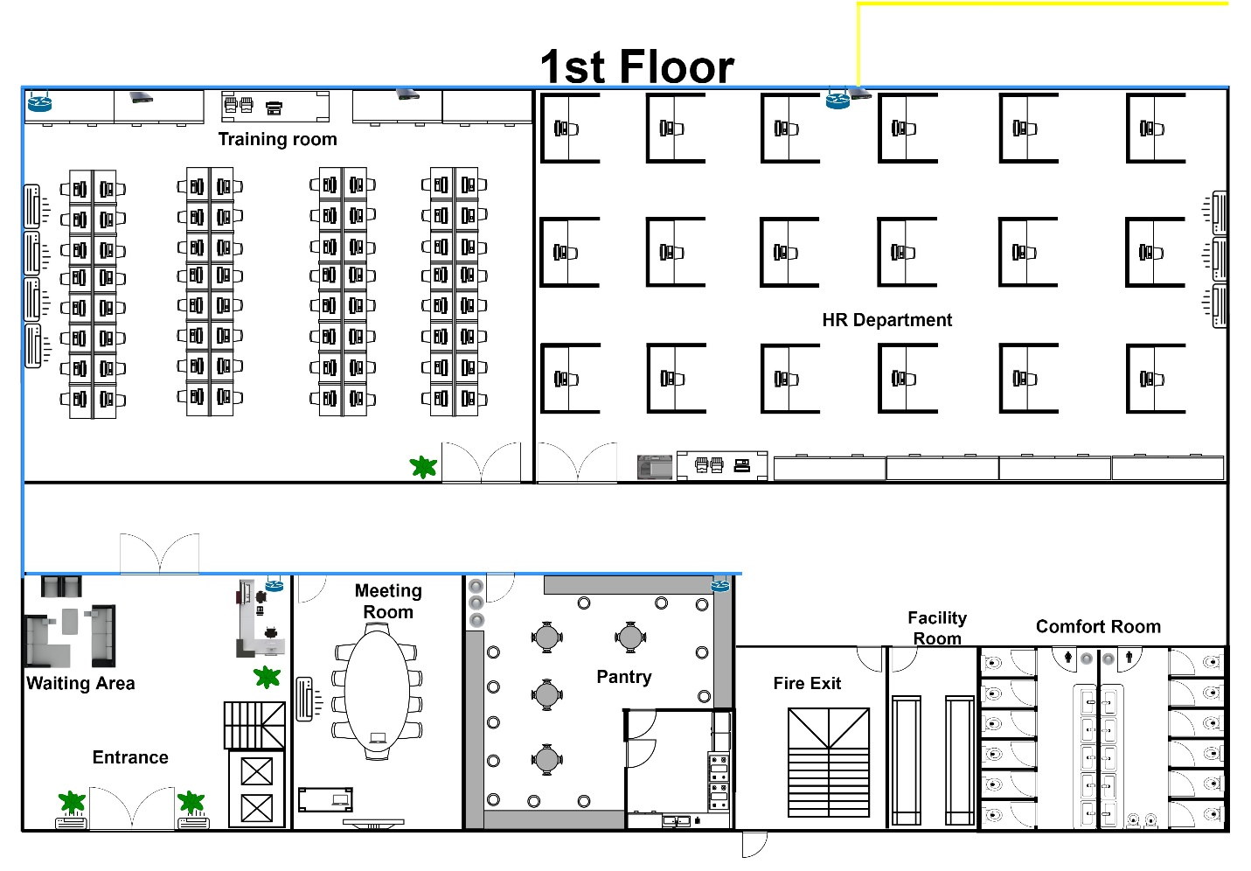

**1st Floor**

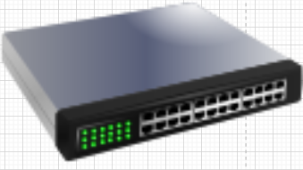**Legend**

|  |  |  |
| --- | --- | --- |
| Router | Wireless Router | Switch |
| Raceway | Backbone  Raceway |  |

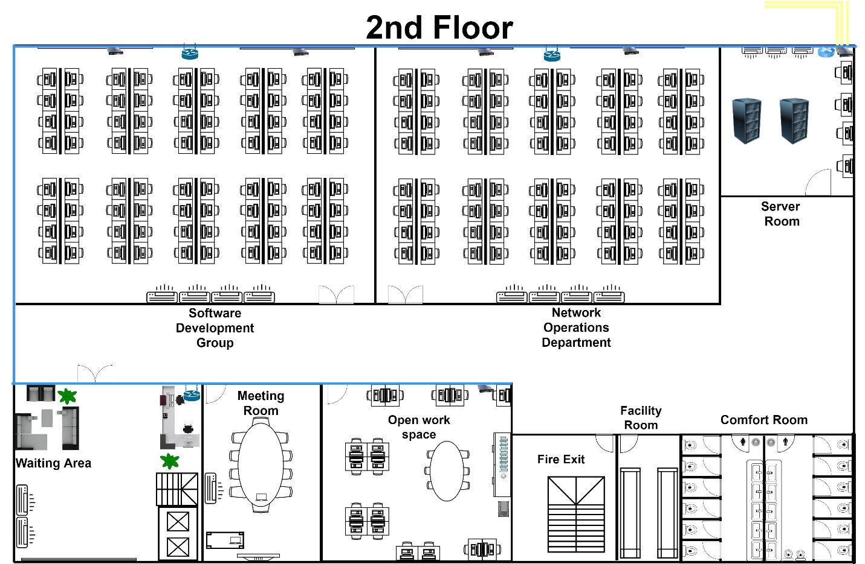

**2nd Floor**

**Legend**

|  |  |  |
| --- | --- | --- |
| Router | Wireless Router | Switch |
| Raceway | Backbone  Raceway |  |

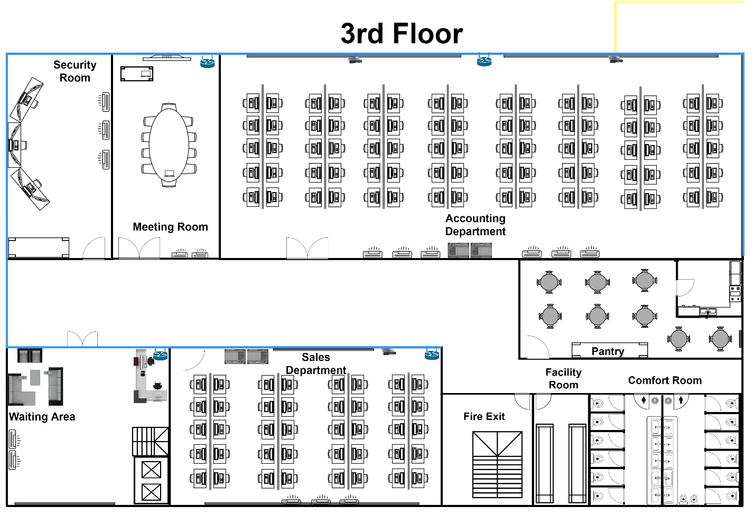

**3rd Floor**

**Legend**

|  |  |  |
| --- | --- | --- |
| Router | Wireless Router | Switch |
| Raceway | Backbone  Raceway |  |

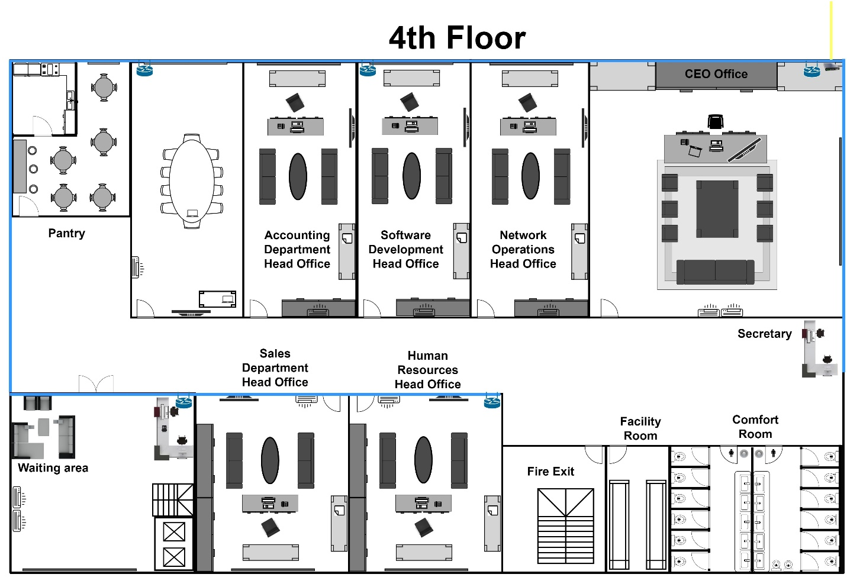

**4th Floor**

**Legend**

|  |  |  |
| --- | --- | --- |
| Router | Wireless Router | Switch |
| Raceway | Backbone  Raceway |  |

1. 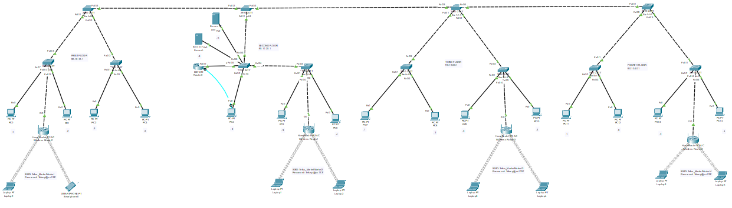Layout of all MDFs and IDFs
2. An IP addressing scheme for all devices on the network.

|  |  |  |
| --- | --- | --- |
| **FLOOR** | **IP ADDRESS** | **RESERVED IP** |
|  |  |  |
| First Floor | 90.10.10.1 |  |
| First Floor PC IP Addresses | 90.10.10.1 to 90.10.10.93 | 90.10.10.94 to 90.10.10.255 |
| Default Gateway | 90.10.20.1 |  |
|  |  |  |
| Second Floor | 90.10.20.1 |  |
| Second Floor PC IP Addresses | 90.10.20.2 to 90.10.20.185 | 90.10.20.186 to 90.10.20.255 |
| Default Gateway | 90.10.20.1 |  |
|  |  |  |
| Third Floor | 90.10.30.1 |  |
| Third Floor PC IP Addresses | 90.10.30.1 to 90.10.30.124 | 90.10.30.125 to 90.10.30.255 |
| Default Gateway | 90.10.20.1 |  |
|  |  |  |
| Fourth Floor | 90.10.40.1 |  |
| Fourth Floor PC IP Addresses | 90.10.40.1 to 90.10.40.8 | 90.10.40.9 to 90.10.40.255 |
| Default Gateway | 90.10.20.1 |  |

|  |  |
| --- | --- |
| **SERVERS** | **IP ADDRESS** |
| Server 1 | 90.10.20.5 |
| Server 2 | 90.10.20.6 |

1. A cost projection for the implementation of the network, including:
2. Equipment purchases costs.
3. Cabling and testing costs
4. Equipment installation costs
5. Training and support costs

|  |  |  |  |  |  |
| --- | --- | --- | --- | --- | --- |
| Description | Name of Item | No. Items | Remarks | Status | Total Project Cost |
| Equipment Purchase | System Unit (IT department) | 250 | 140 are placed in the new infrastructure, 110 are for the backups. | Installation and Set-up Successfully Completed | P23,247,500.00 |
| System Unit (HR, Sales, and Accounting department) | 250 | 110 are placed in the new infrastructure, 140 are for the backups. | P2,175,000.00 |
| Monitor | 500 | 300 are placed in the new infrastructure, 200 are for the backups. | P3,649,500.00 |
| Mouse | P162,500.00 |
| Keyboard | P1,195,000.00 |
| Server PC (Full Set) | 2 |  | Installation and Set-up Successfully Completed | P323,600.00 |
| Laptop | 100 |  | Installation and Set-up Successfully Completed | P9,139,200.00 |
| UPS server | 500 |  | Installation and Set-up Successfully Completed | P1,500,000.00 |
| UPS server (for Server PC) | 2 |  | Installation and Set-up Successfully Completed | P12,000.00 |
| Switch | 30 |  | Installation and Set-up Successfully Completed | P286,680.00 |
| Wireless Router | P114,660.00 |
| Router | P352,650.00 |
| Cables | P24,355.50 |
| Cabling and testing | Cabling and Testing Tools |  |  | Successfully Completed | P3,000,000.00 |
| Equipment installation | Network and IT Support service |  |  | Successfully Completed | P3,400,000.00 |
| Training and support | Network, IT Support, and End User |  |  | Successfully Completed | P2,900,000.00 |
| TOTAL: | | | | P50,582,645.50 | |

|  |  |  |  |  |
| --- | --- | --- | --- | --- |
| Items | | Details & Specs | Manufacturer | Unit Price |
| System Unit (IT department) |  | **Dell G5 5090**   * Intel Core i7-9700 (8-Core/8-Thread 12M Cache, 4.7GHz Processor with Intel Turbo Boost Technology) * NVIDIA GeForce GTX 1660 Ti 6GB GDDR6 * RAM 16GB * Memory Type DDR4 * Memory Speed 2666MHz * Storage Type HDD+SSD/eMMC * HDD 2TB * HDD Format 3.5 inches * Rotational Speed 7200 rpm * SSD/Emmc 256GB * Ethernet RJ45 * WiFi Killer 1650X 802.11ax 2x2 built on Intel WiFi 6 Chipset * Connectivity Connectivity HDMI , USB2.0 , USB3.0 , Bluetooth , Microphone , USB Type-C , USB3.1 * Software OS Windows 10, OS Ver Windows 10 Home, Windows 10 Pro * Size Dimensions 367 x 169 x 308 mm * Weight Starting at 8.43 kg | DELL | P92,990.00 |
| System Unit (HR, Sales, Accounting department) |  | **Dell Optiplex 3020 SFF**   * CPU Core i5 * 4th Gen Intel Core i5-4590 * 4gb RAM * 512GB HDD | DELL | P8,700.00 |
| Monitor |  | **Xiaomi Mijia 23.8 Inch**  IPS Hard Screen 178 ° Super Wide Viewing Angle 1080P HD Computer Multi-Interface | Xiaomi | P7,299.00 |
| Mouse |  | **M100 Corded Mouse** | Logitech | P325.00 |
| Keyboard |  | **Xiaomi MIIIW Gaming Mechanical Keyboard 600K** | Xiaomi | P2,390.00 |
| Server PC (Full Set) |  | **DEEPCOOL CL 500**  **AMD Ryzen 9 5900X**  **MSI MED X570 ace**  **G.Skill Ripjaws V 128GB**  **Asus GTX 1650 OC 4GB**  **NZXT Kraken Z73 360mm AIO**  **Seagate Barracuda 2TB x4**  **Samsung 970 EVO plus 1Tb NVMe**  **EVGA 700 BQ 80+ bronze**  **Deepcool RF120 pack** |  | P161,800.00 |
| Laptop |  | **ThinkPad X1 Carbon Gen 8 (14”)**  Up to 10ᵗʰ Generation Intel® Core™ i7-10610U Processor with vPro™ (1.80 GHz, up to 4.90 GHz with Turbo Boost, 4 Cores, 8 Threads, 8 MB Cache) | LENOVO | P91,392.00 |
| UPS server |  | **Secure UPS 1500VA Uninterruptible Power Supply** | SECURE | P3,000.00 |
| UPS server (for Server PC) |  | **SECURE 3000VA UPS** | SECURE | P6,000.00 |
| Switch | Netgear 48-Port GS348 Gigabit Unmanaged Switch GS348-100NAS B&amp;H | **NETGEAR 48-Port Gigabit Ethernet Unmanaged Switch (GS348) - Desktop or Rackmount, Silent Operation** | NETGEAR | P9,556.00 |
| Wireless Router |  | **Tenda AC23 Smart WiFi Router**  Dual Band Gigabit Wireless (up to 2033 Mbps) Internet Router for Home, 4X4 MU-MIMO Technology, Up to 1400 sq ft Coverage Parental Control Compatible with Alexa (AC2100) | Tenda | P3,822.00 |
| Router |  | **Ubiquiti Networks EdgeRouter 12, 10-Port Gigabit Router with PoE Passthrough and 2 SFP Ports (ER-12)** | Ubiquiti | P11,755.00 |
| Cable |  | **Cable Matters Snagless Long Cat6 (SSTP, SFTP) Shielded Ethernet Cable in Black 50 ft** | Cable Matters | P811.25 |

* 1. **Objectives**

***Specific Objectives***

* To design the physical and logical layouts for the network infrastructure of the new TELUS bldg.
* To construct a simulation facility to represent an established and improved network infrastructure.
* To deploy the proposed structured cabling design.
* To design and implement a cabling facility.
* Acquisition of Devices & Applications.
* To identify and acquire the necessary Network Devices & Equipments.
  + Budget
  + Device
  + Application

|  |  |  |
| --- | --- | --- |
| **DEVICE** | **BUDGET** | **TOTAL PROJECT COST** |
| System Unit (IT department) | P25,000,000.00 | P23,247,500.00 |
| System Unit (HR, Sales, and Accounting department) | P3,000,000.00 | P2,175,000.00 |
| Monitor | P4,000,000.00 | P3,649,500.00 |
| Mouse | P170,000.00 | P323,600.00 |
| Keyboard | P1,500,000.00 | P1,195,000.00 |
| Server PC (Full Set) | P170,000.00 | P161,800.00 |
| Laptop | P10,000,000.00 | P9,139,200.00 |
| UPS server | P2,000,000.00 | P1,500,000.00 |
| UPS server (for server PC) | P20,000.00 | P12,000.00 |
| Switch | P300,000.00 | P286,680.00 |
| Wireless Router | P150,000.00 | P114,660.00 |
| Router | P400,000.00 | P352,650.00 |
| Cables | P25,000.00 | P24,355.50 |
| **Applications** | | |
| Standard Software Applications  Adobe Acrobat Professional  Cisco  Service Now  Out of Scope Application (3rd Party Application if any) | P50,000,000.00 | P 12,660,412.6 |
| TOTAL: | | P 63,243,058.10 |

* 1. **Logical Configuration of Telus Network**
* Codes per router

Router>ena

Router#config t

Enter configuration commands, one per line. End with CNTL/Z.

Router(config)#hostname Telus_MarketMarket

Telus_MarketMarket(config)#ena password P@ssword123!

Telus_MarketMarket(config)#int fa0/0

Telus_MarketMarket(config-if)#ip add 90.10.20.1 255.0.0.0

Telus_MarketMarket(config-if)#no shut

Telus_MarketMarket(config-if)#

%LINK-5-CHANGED: Interface FastEthernet0/0, changed state to up

%LINEPROTO-5-UPDOWN: Line protocol on Interface FastEthernet0/0, changed state to up

exit

Telus_MarketMarket(config)#exit

Telus_MarketMarket#

%SYS-5-CONFIG_I: Configured from console by console

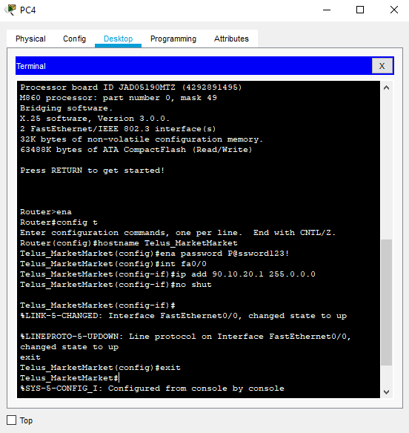

* Up and running configurations of Logical Network

Telus_MarketMarket>ena

Password:

Telus_MarketMarket#show run

Building configuration...

Current configuration : 550 bytes

!

version 12.2

no service timestamps log datetime msec

no service timestamps debug datetime msec

no service password-encryption

!

hostname Telus_MarketMarket

!

!

!

enable password P@ssword123!

!

!

!

!

!

!

ip cef

no ipv6 cef

!

!

!

!

!

!

!

!

!

!

!

!

!

!

!

!

!

!

interface FastEthernet0/0

ip address 90.10.20.1 255.0.0.0

duplex auto

speed auto

!

interface FastEthernet0/1

no ip address

duplex auto

speed auto

shutdown

!

ip classless

!

ip flow-export version 9

!

!

!

no cdp run

!

!

!

!

!

!

line con 0

!

line aux 0

!

line vty 0 4

login

!

!

!

end

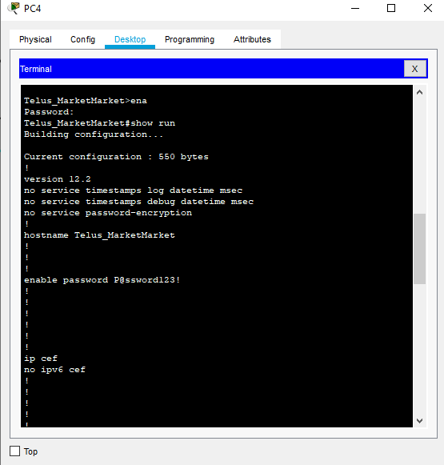

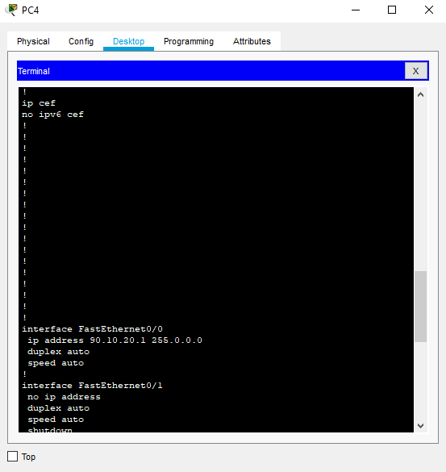

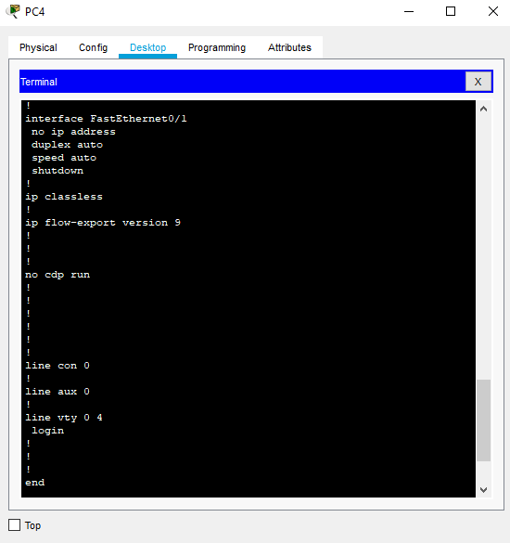

* 1. **Installation, Configuration, and Deployment of the following servers:**
* Installation
* Create new Virtual Machine (Windows 10)

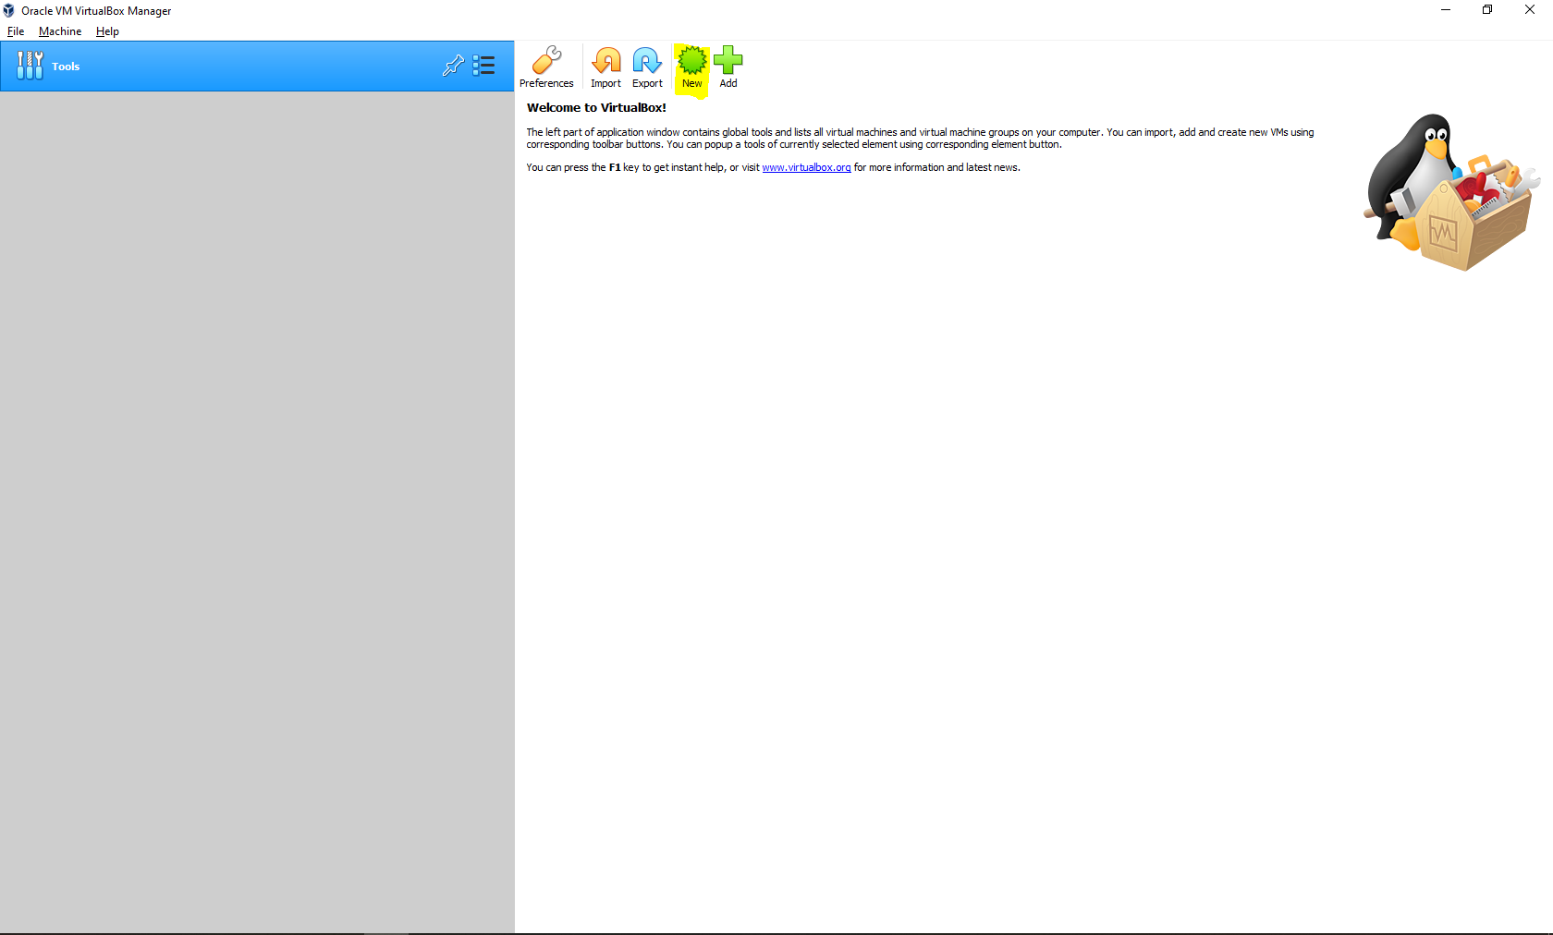

* Input the name of your Virtual Machine and choose the Type and Version that you would use then click next to proceed

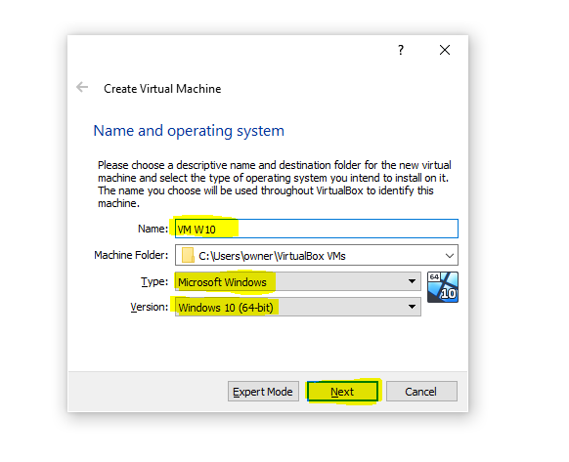

* Create your Virtual Machine Storage then click Next

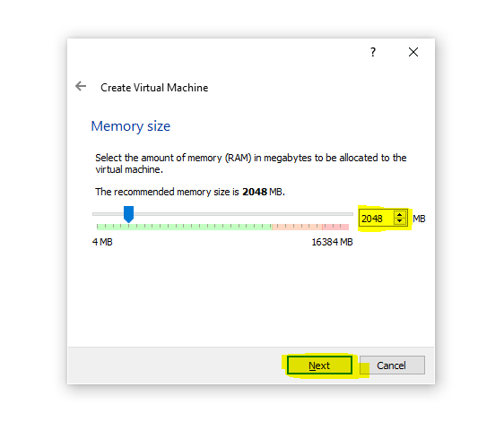

* Choose Create your virtual hard disk now then click create

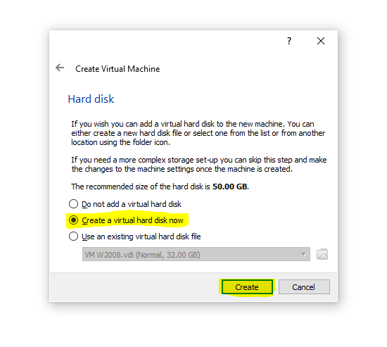

* Choose VDI(VirtualBox Disk Image) then click next to proceed

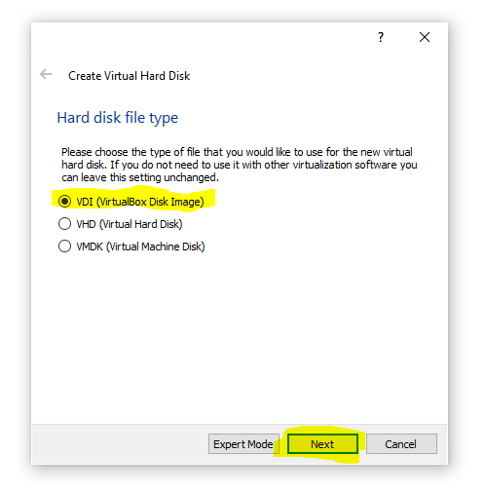

* Choose Dynamically Allocated then click next to proceed

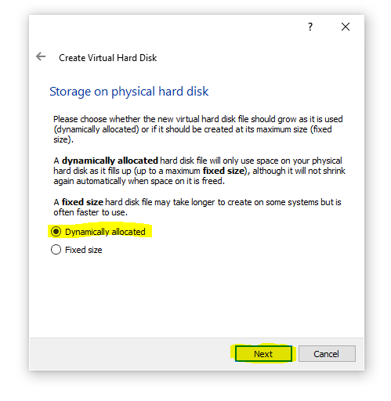

* Choose your Virtual Hard Disk Size then click create to finish setting up your Virtual Machine

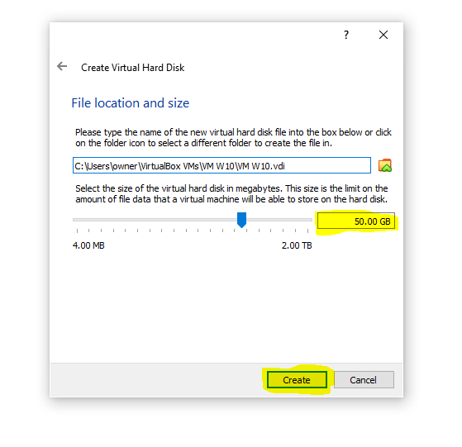

* Click Settings

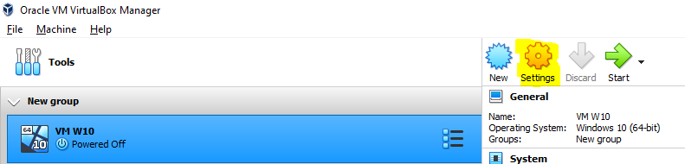

* Click Storage

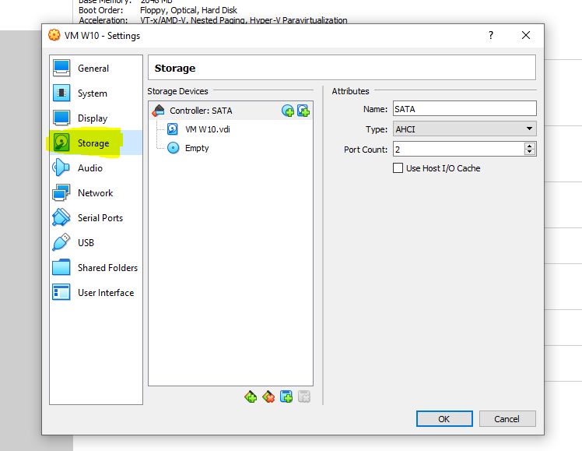

* Click adds new storage attachment

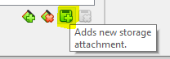

* Click Optical Drive

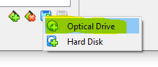

* Click Add to proceed to the directory and locate the windows iso file then click open

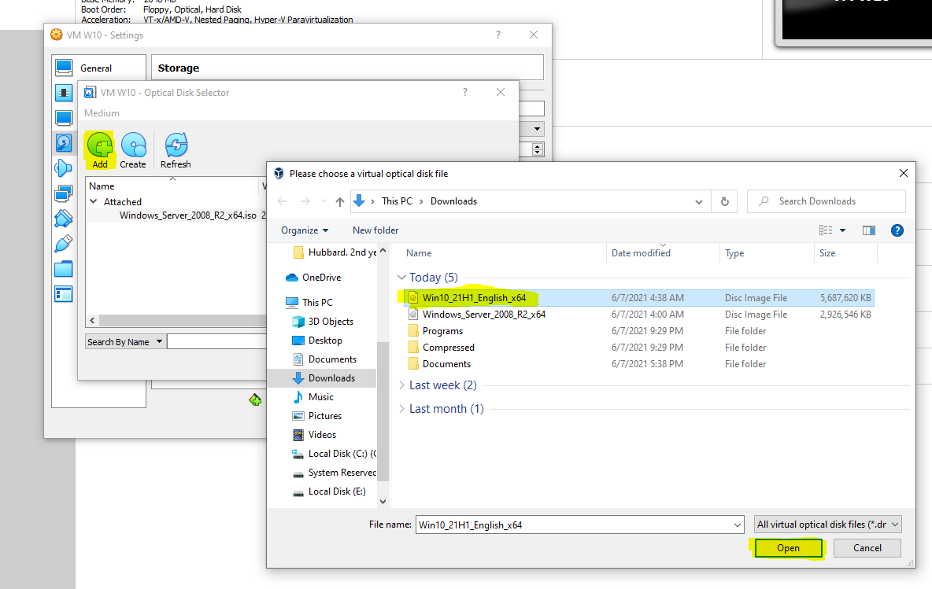

* Click the windows iso file that you will use then click choose to proceed

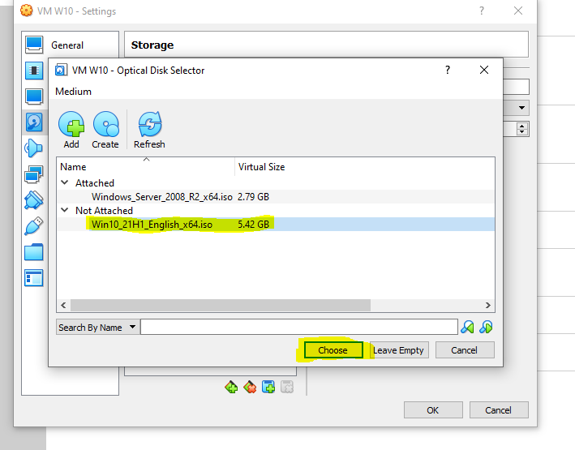

* Start your newly created Virtual Machine

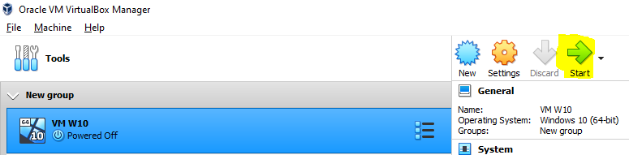

* Choose the language of your windows then click next to proceed

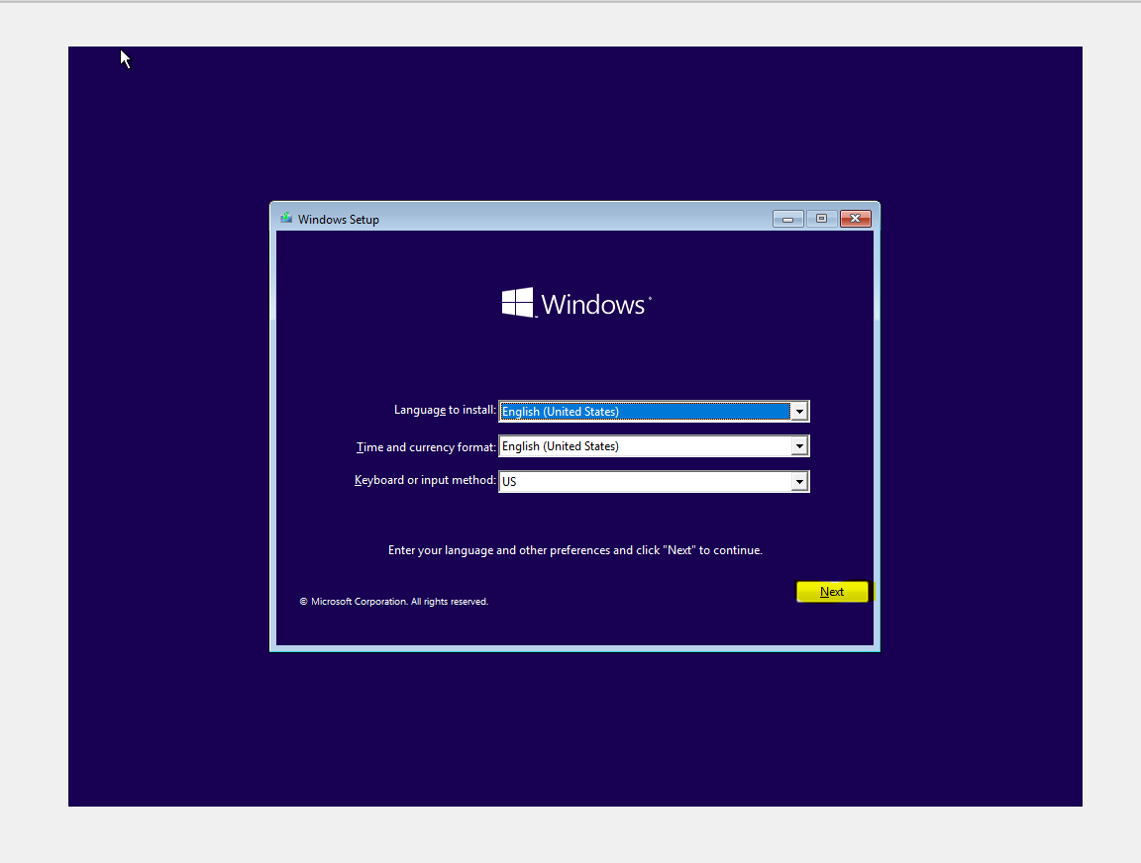

* Click Install Now

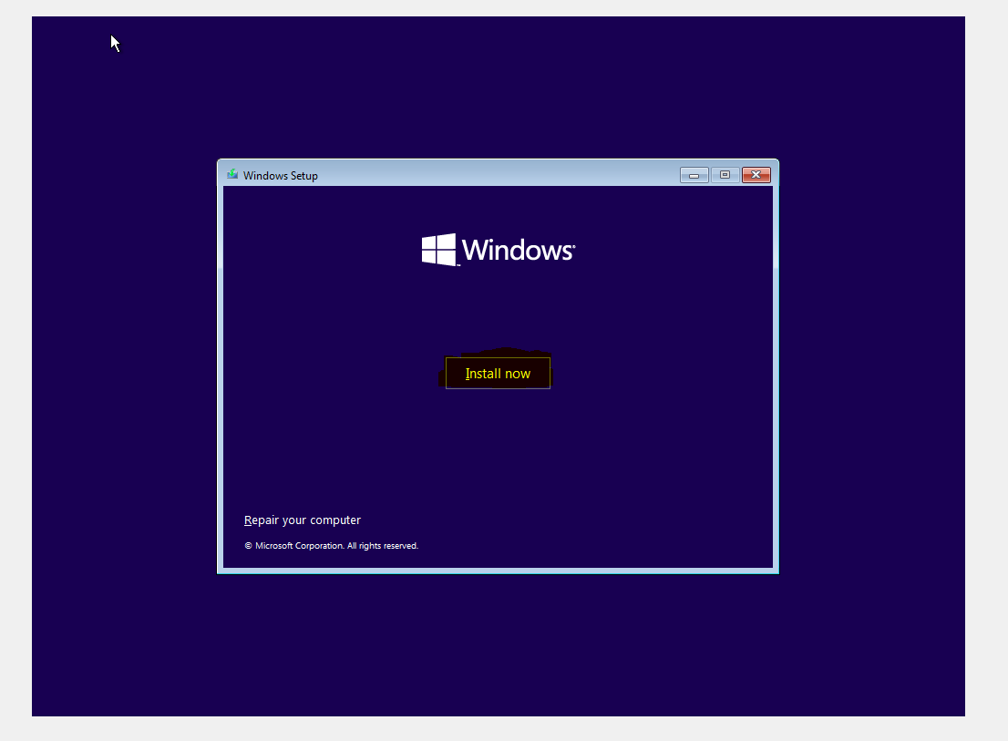

* Select the type and version of windows when you created the Virtual Machine

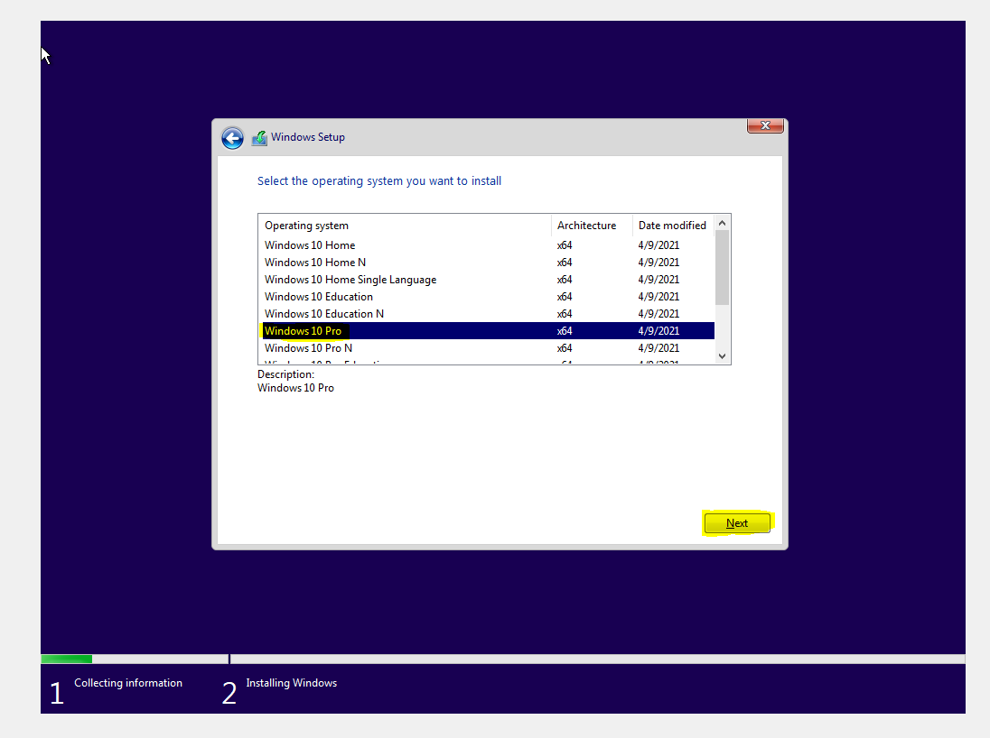

* Choose Custom: Install Windows only (Advanced)

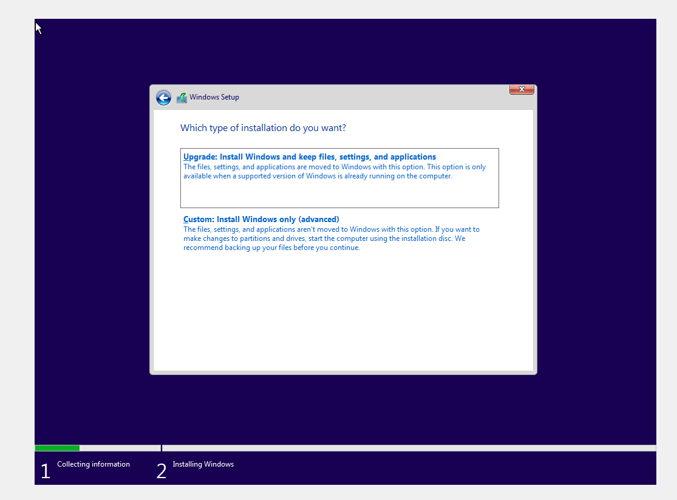

* Installing Windows

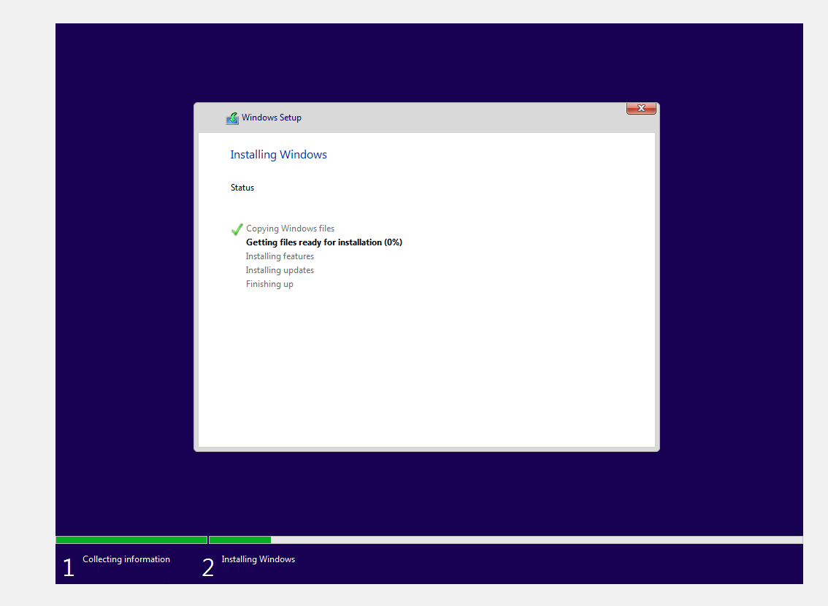

* Input name and click next to proceed

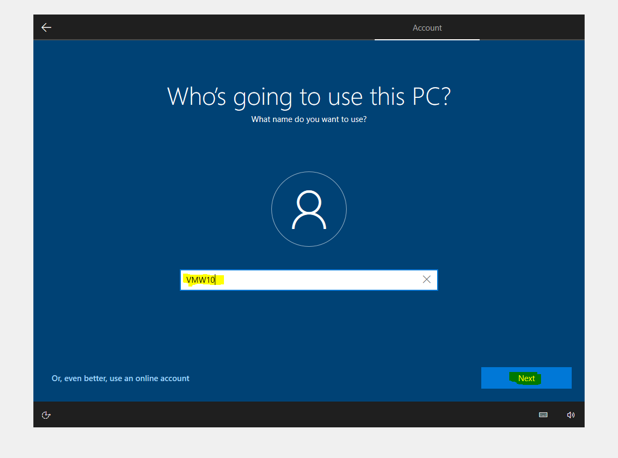

* Input password then click next to proceed

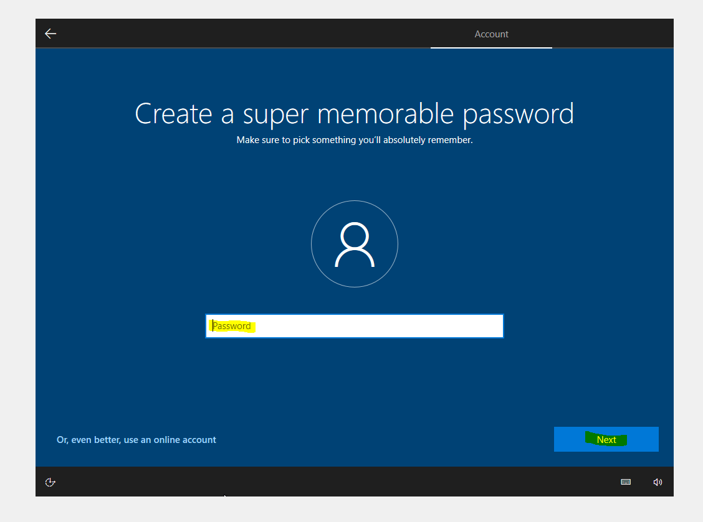

* Finished creating Virtual Machine with Windows 10 Pro

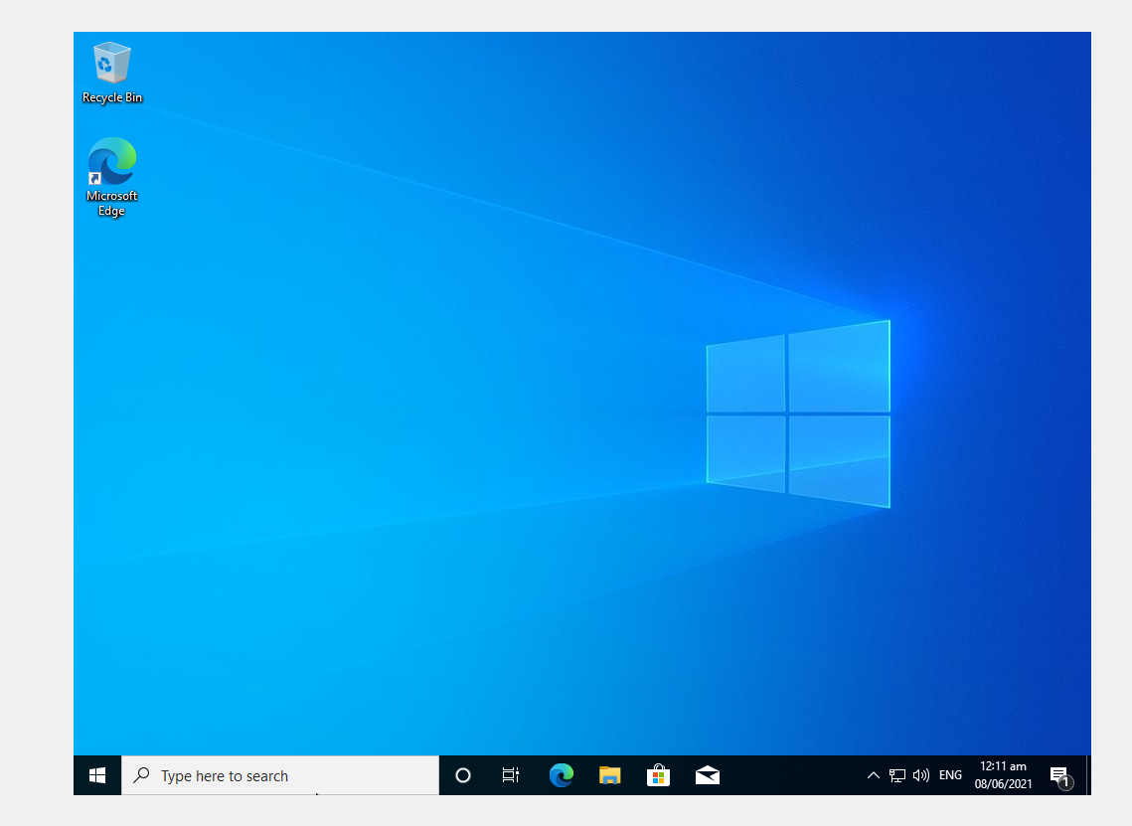

* Create new Virtual Machine (Windows 2008)

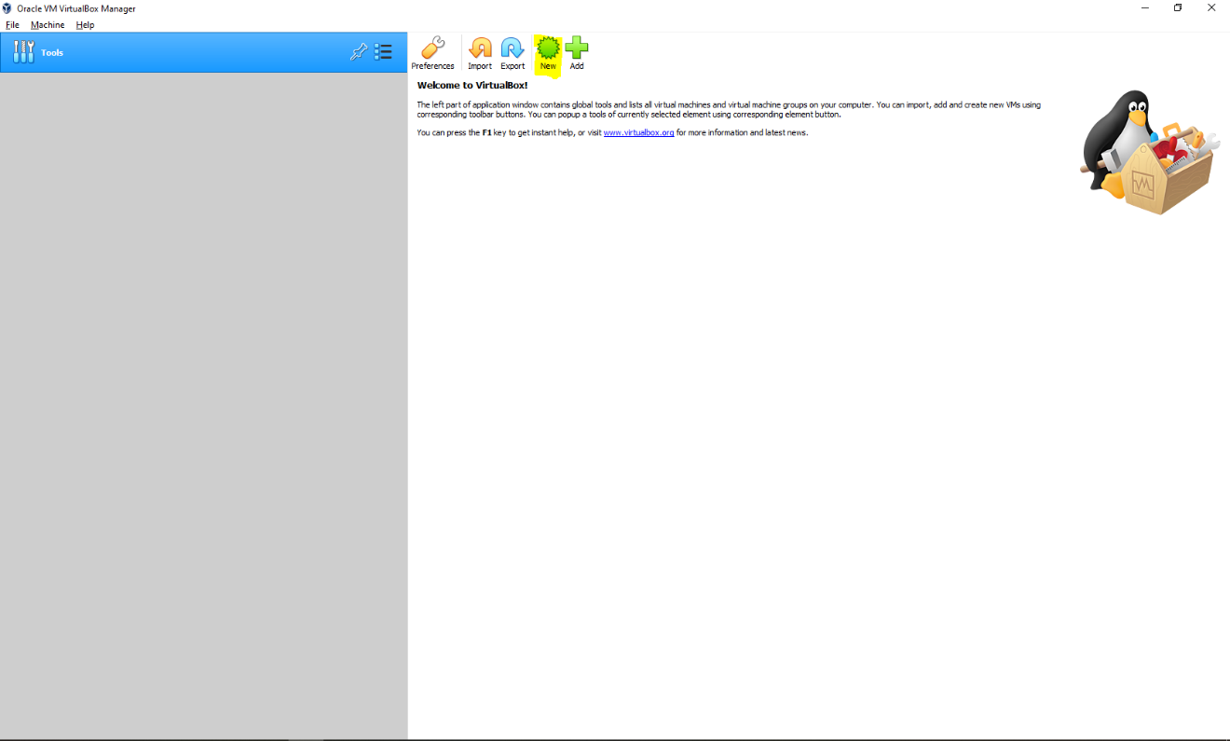

* Input the name of your Virtual Machine and choose the Type and Version that you would use then click next to proceed



* Create your Virtual Machine Storage then click Next



* Choose Create your virtual hard disk now then click create



* Choose VDI(VirtualBox Disk Image) then click next to proceed



* Choose Dynamically Allocated then click next to proceed



* Choose your Virtual Hard Disk Size then click create to finish setting up your Virtual Machine



* Click Settings

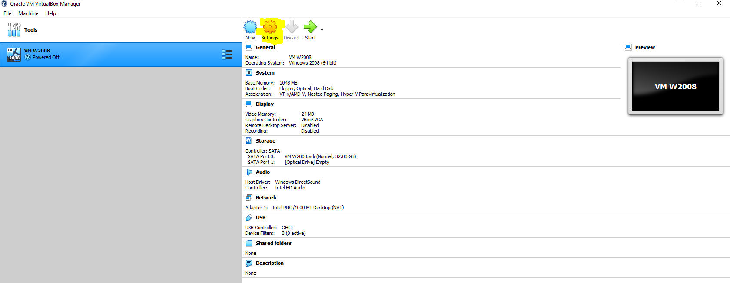

* Click Storage

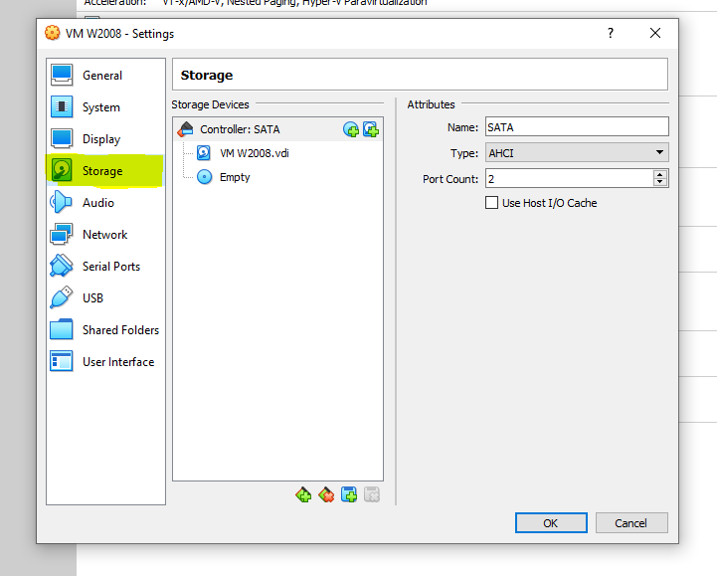

* Add new storage attachment



* Click Optical Drive



* Click Add to proceed to the directory and locate the windows iso file then click open

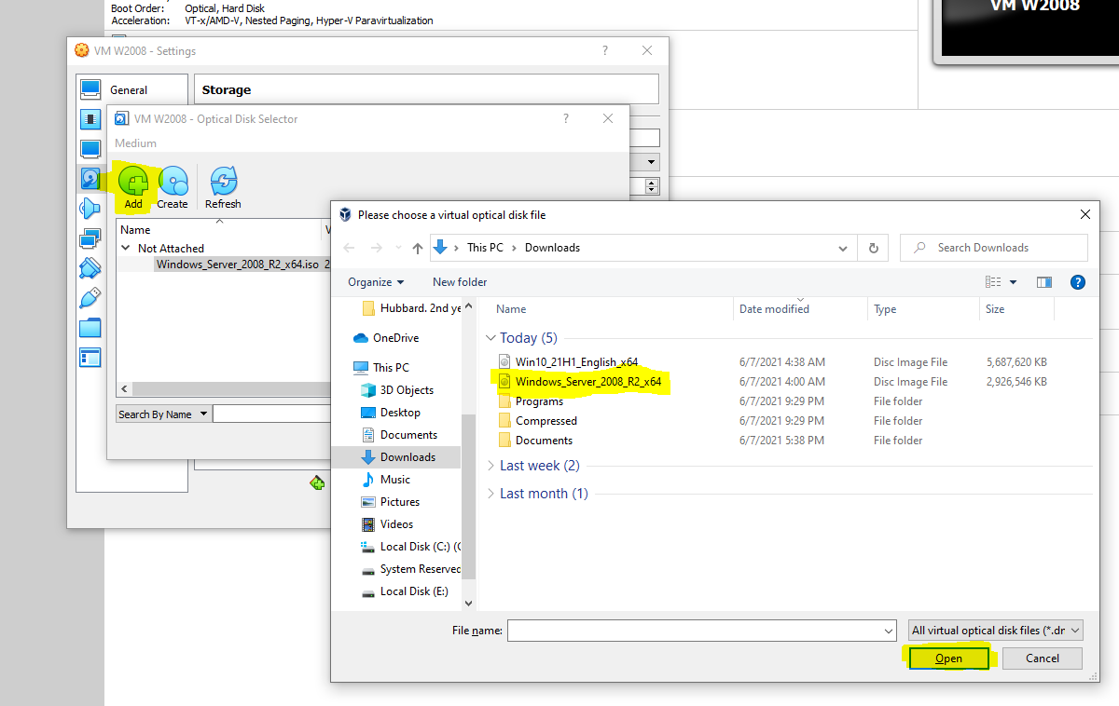

* Click choose to proceed

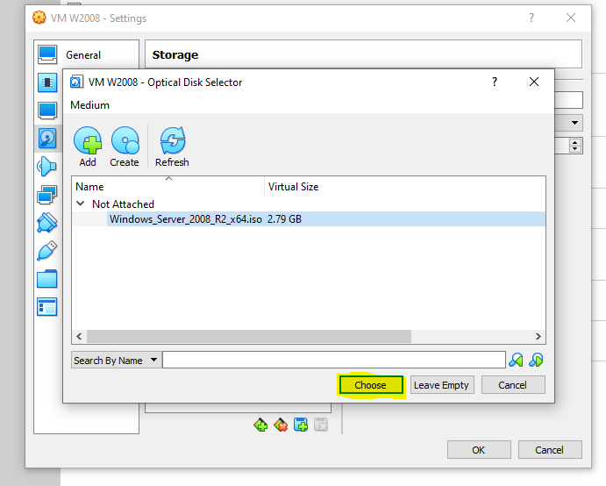

* Click Start

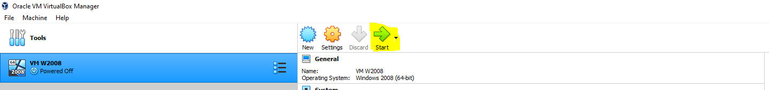

* Click Start to open your Virtual Machine

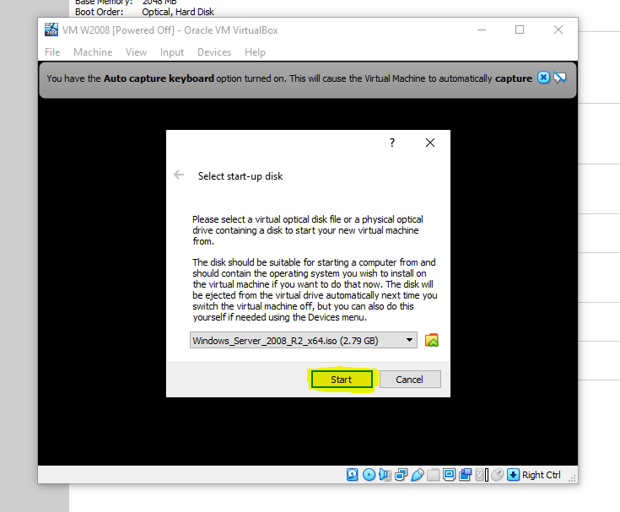

* Choose the language of your windows then click next to proceed

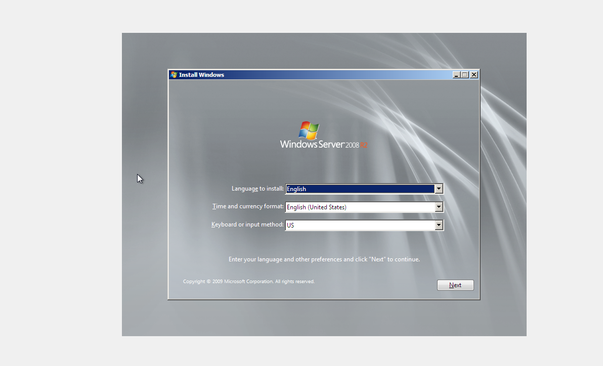

* Click Install now

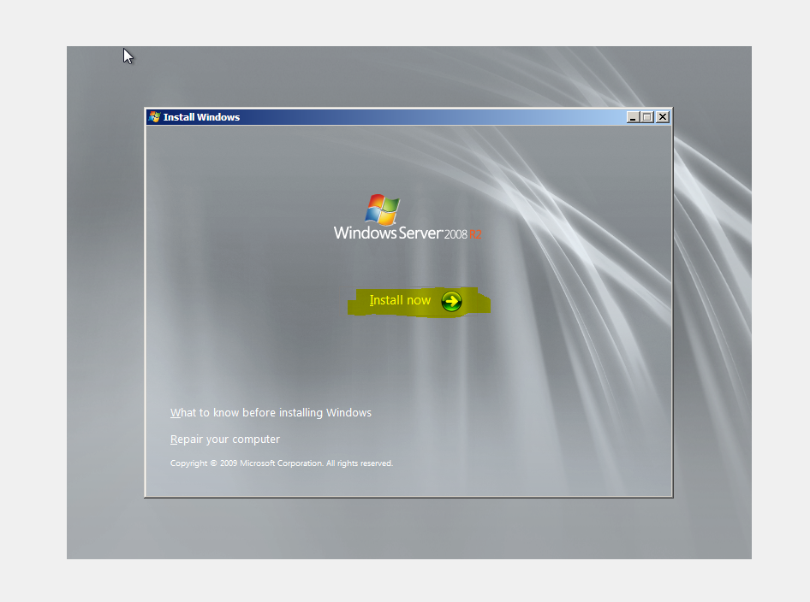

* Select the type and version of windows when you created the Virtual Machine

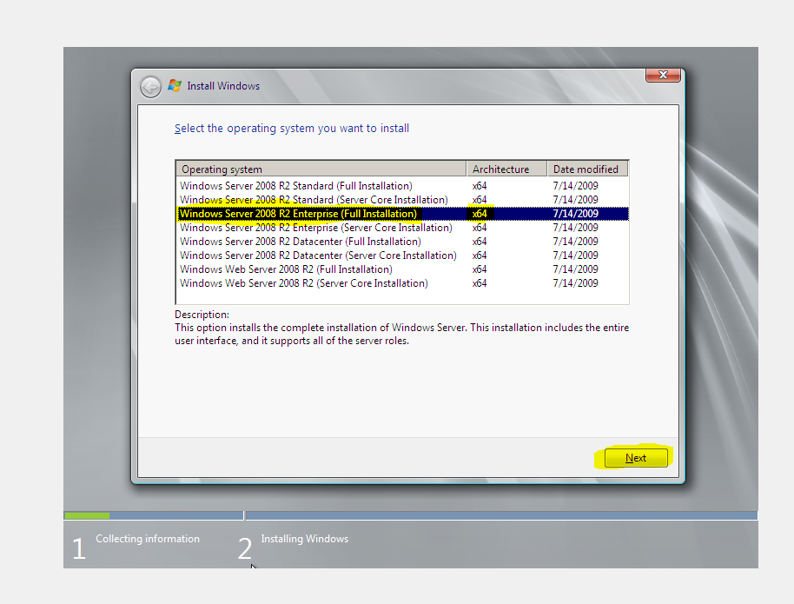

* Choose Custom (advanced)

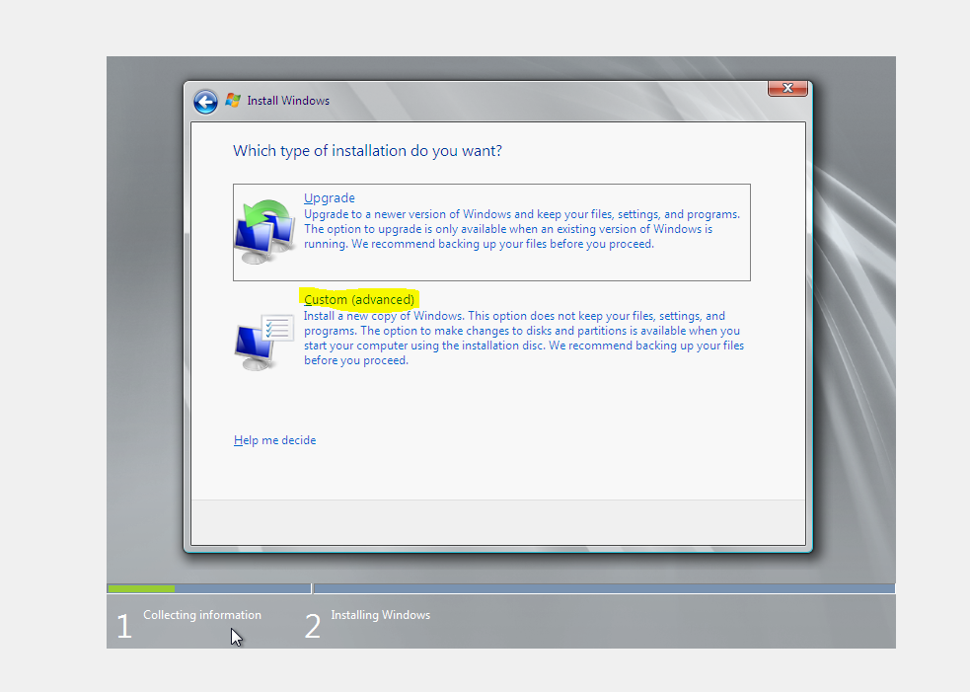

* Installing Windows

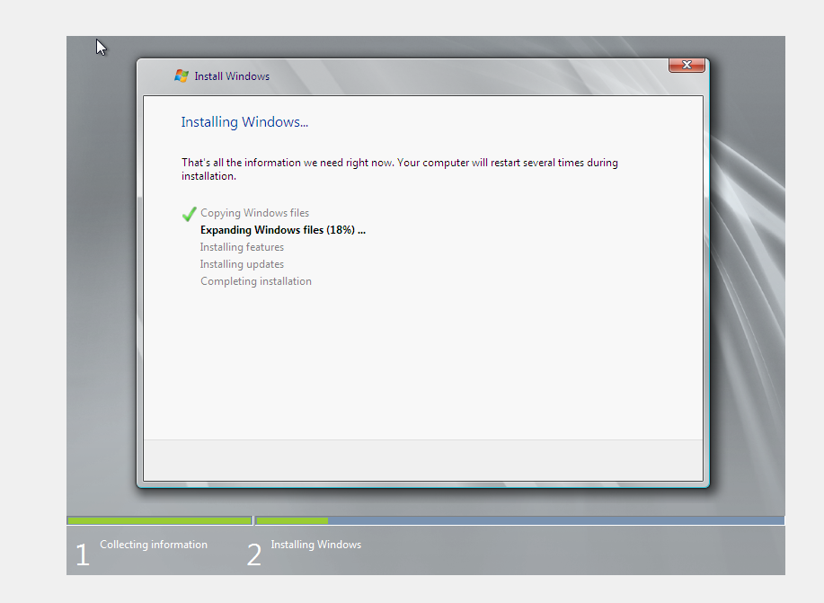

* Input your new password then click the green arrow button

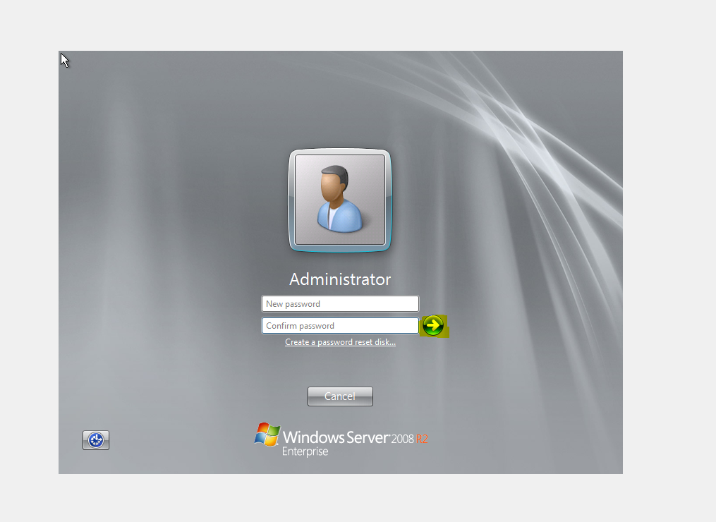

* Finished creating Virtual Machine with Windows 2008 R2 Enterprise

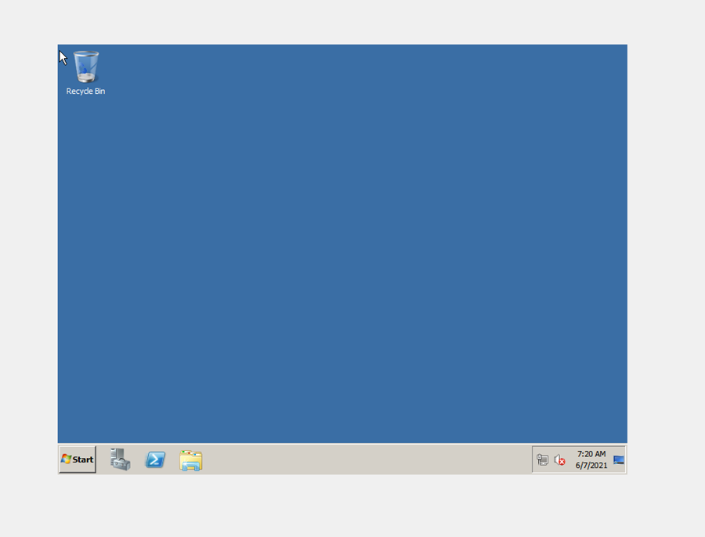

* Setup IP address, Network assigning and testing

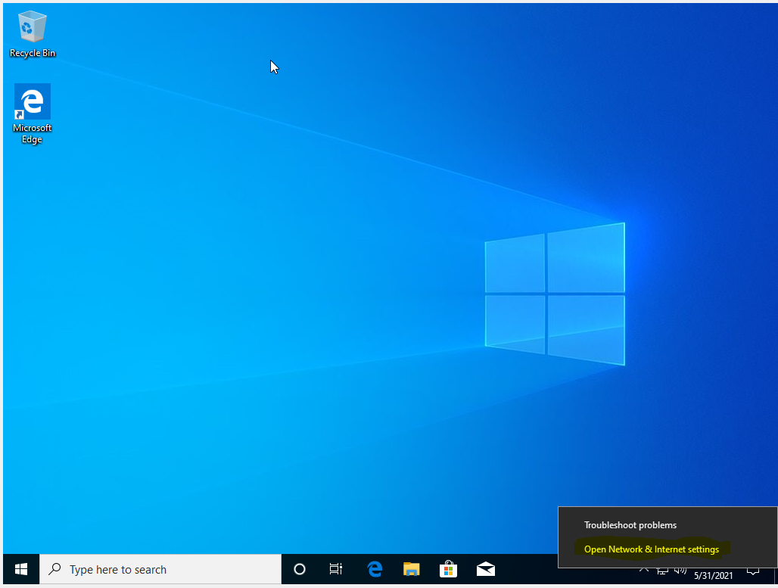

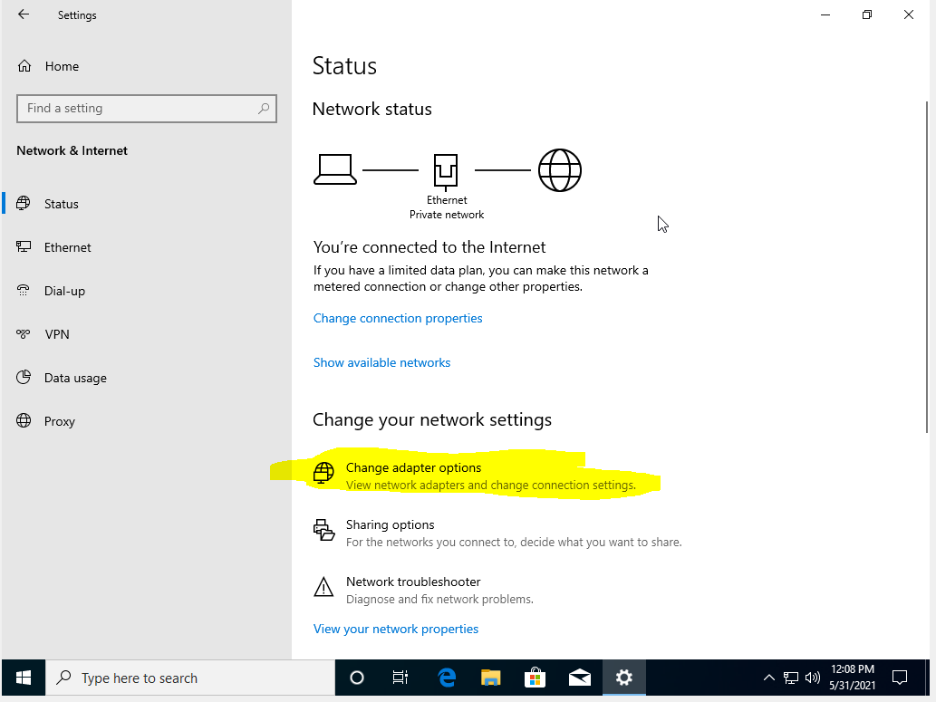

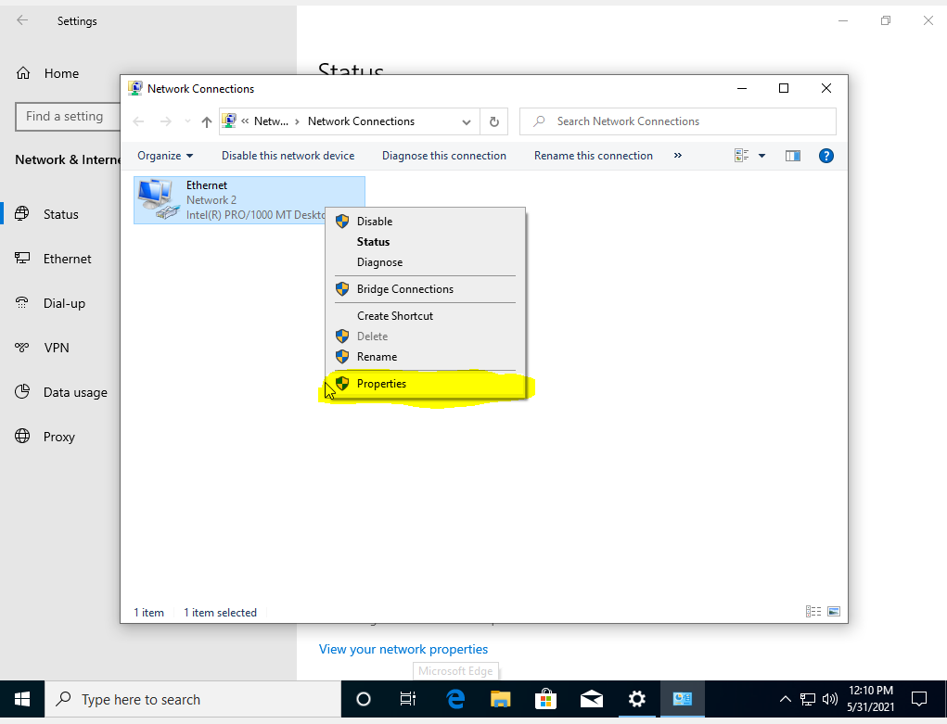

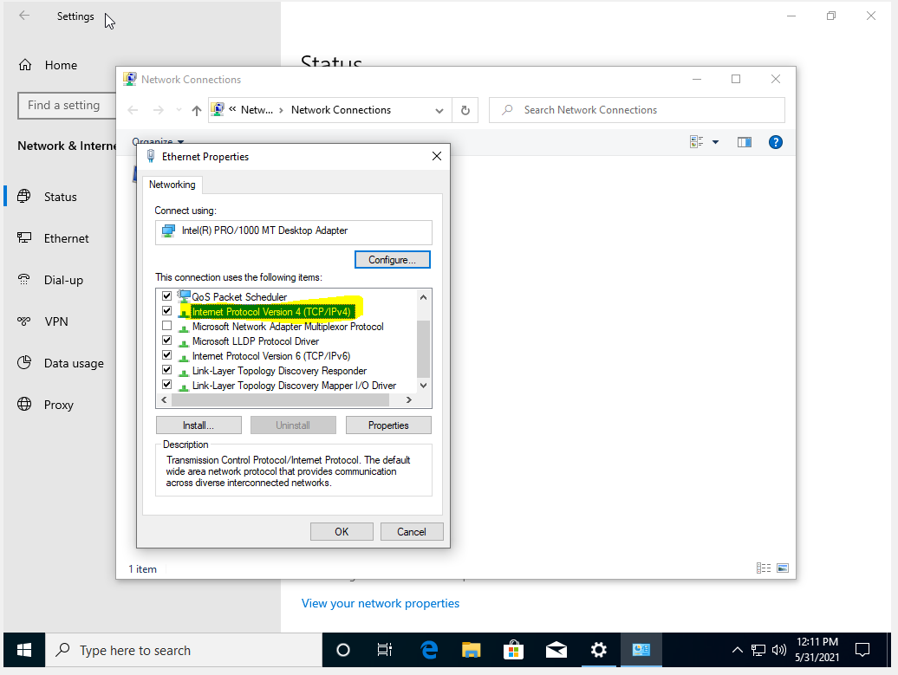

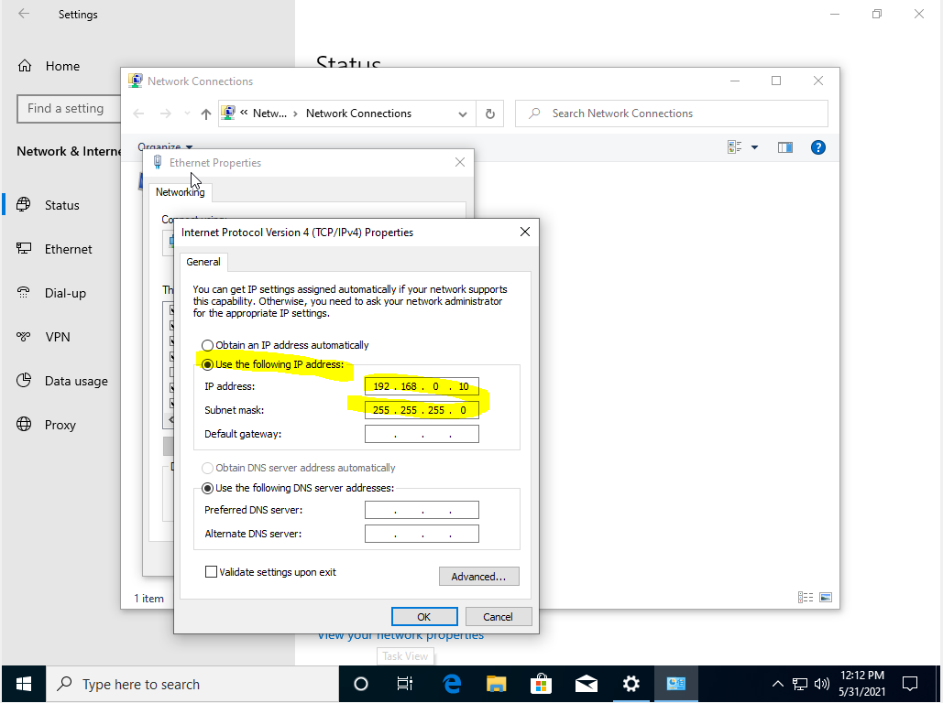

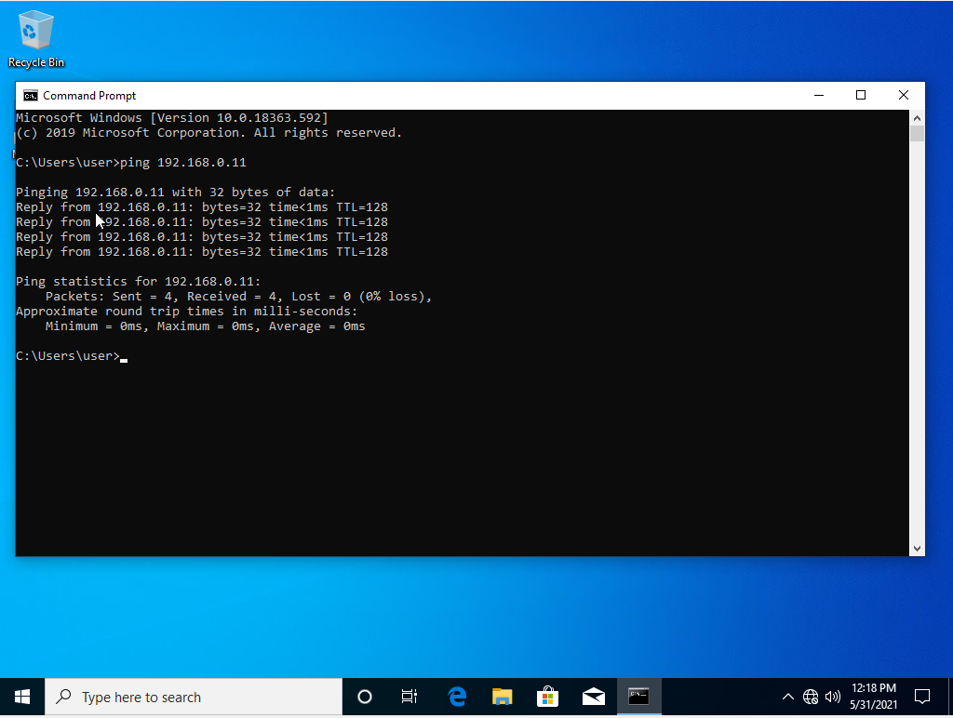

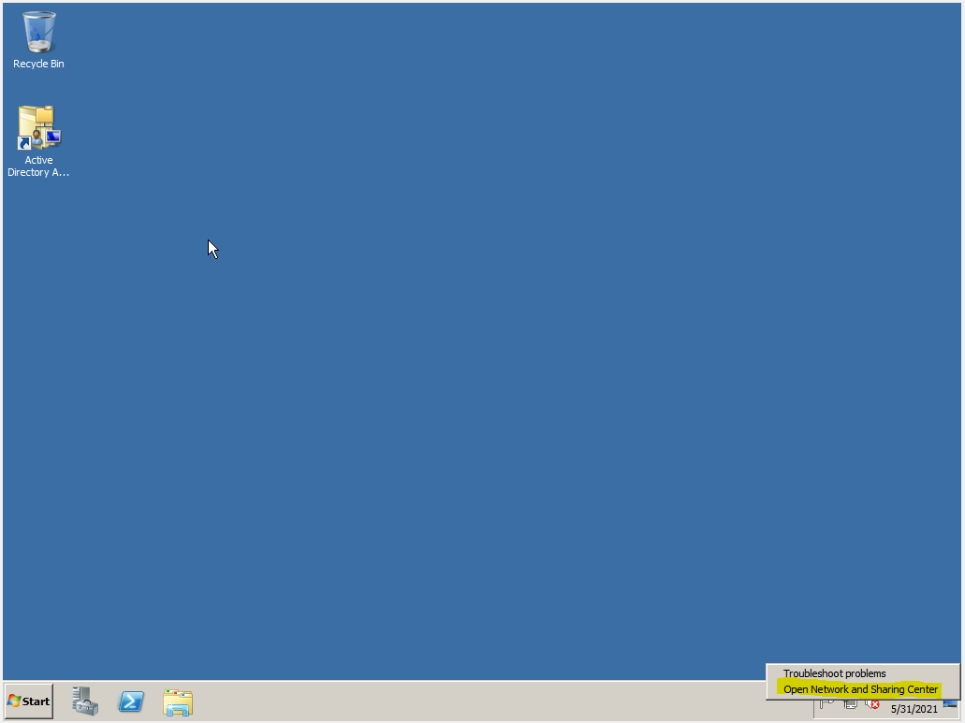

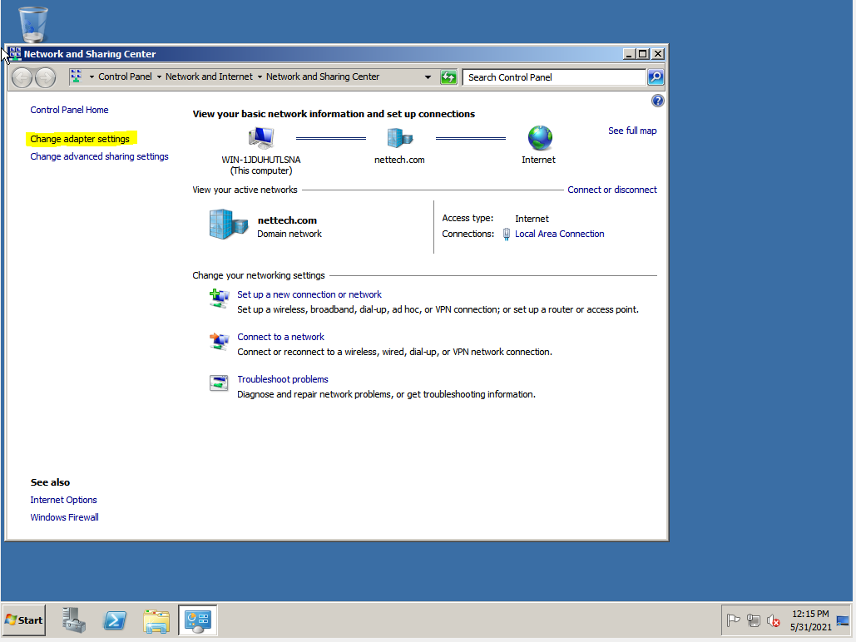

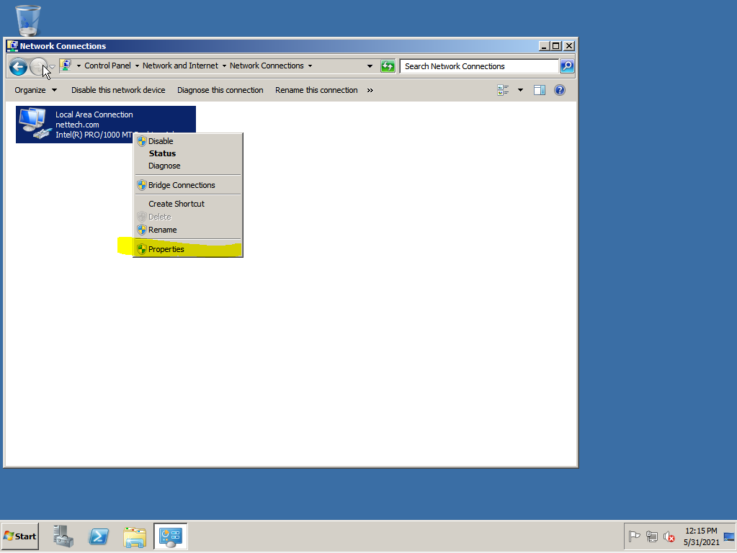

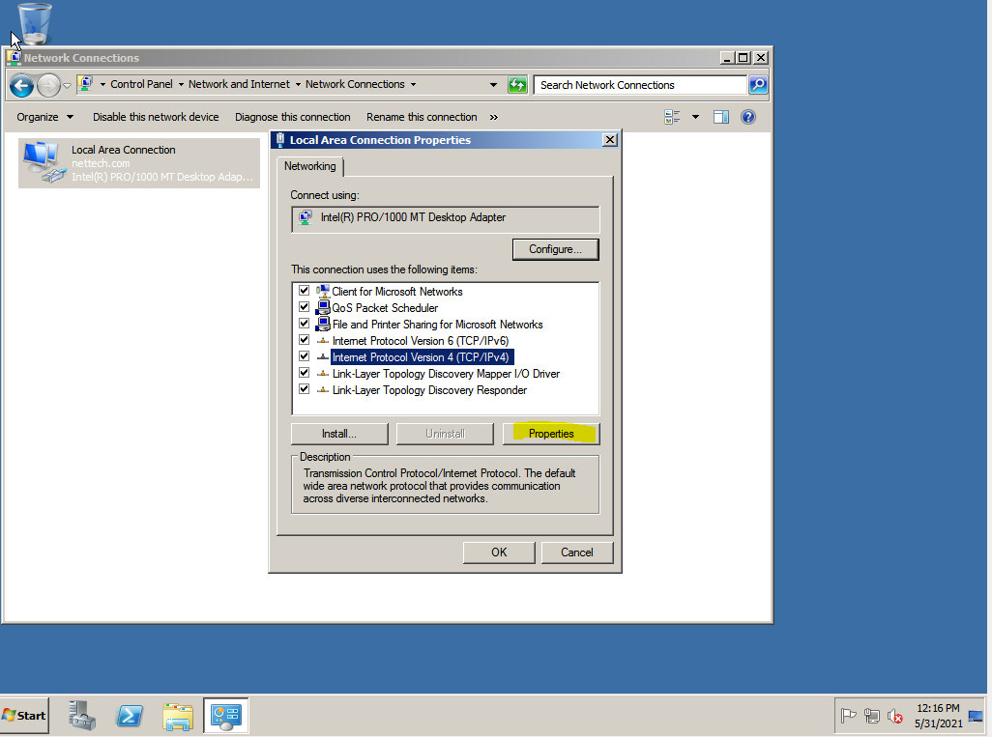

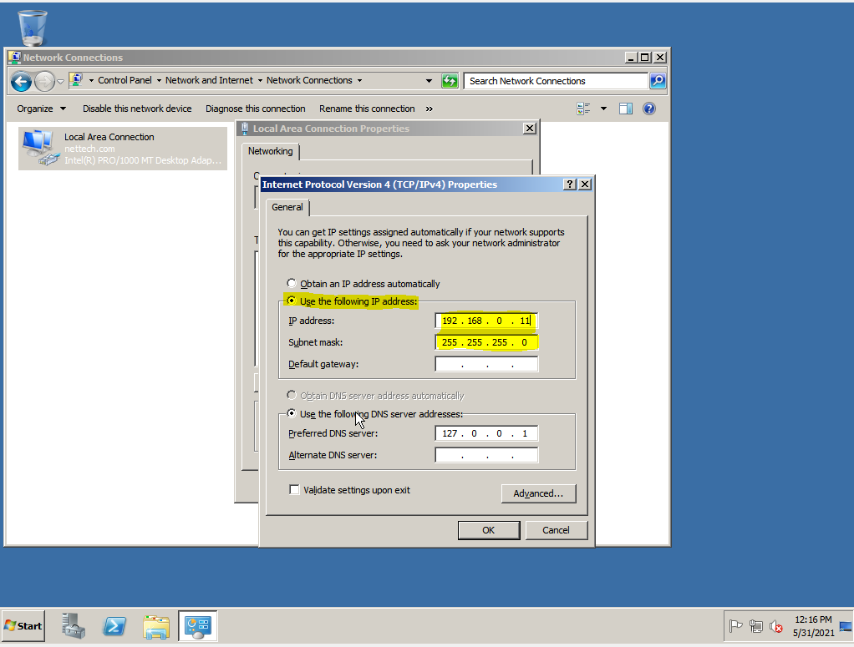

* Bridge

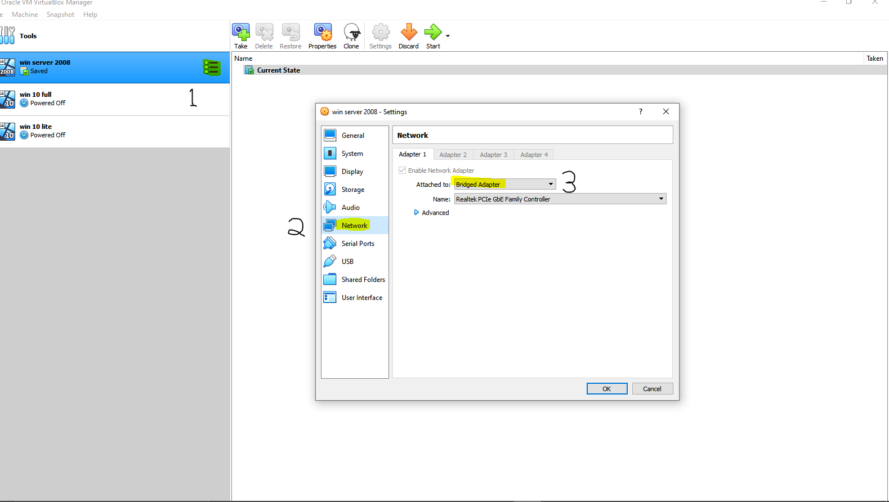

* Account Creation

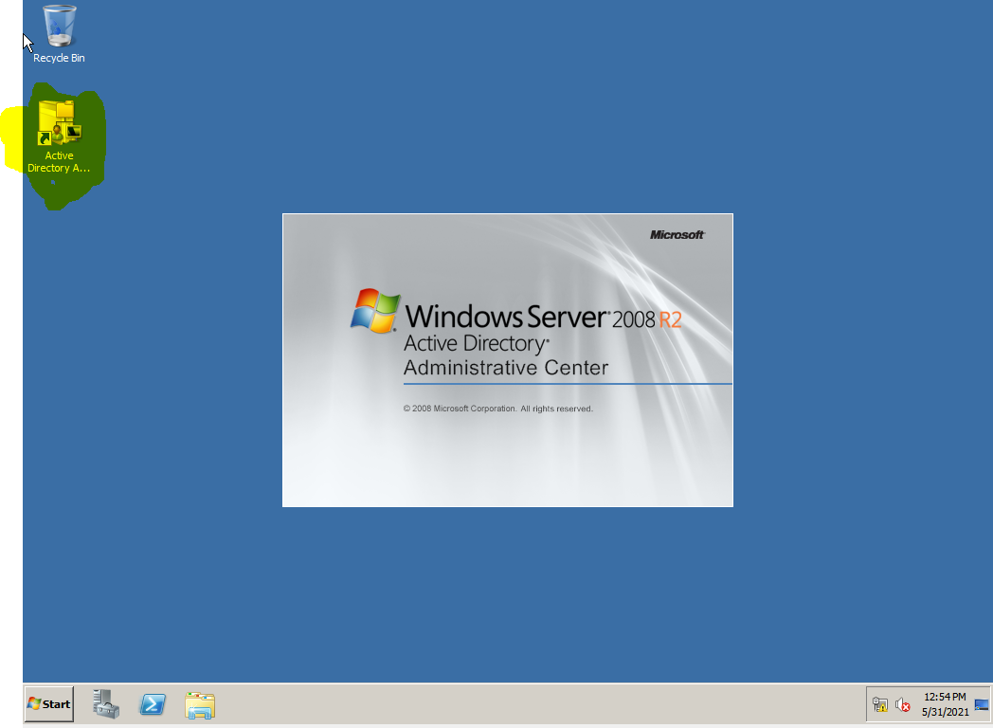

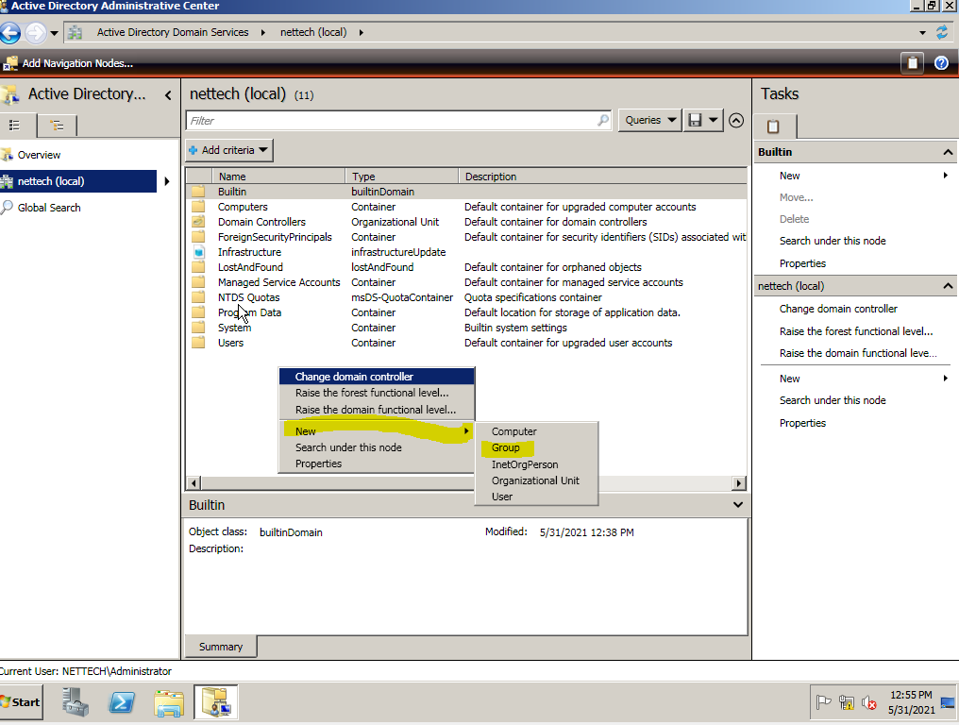

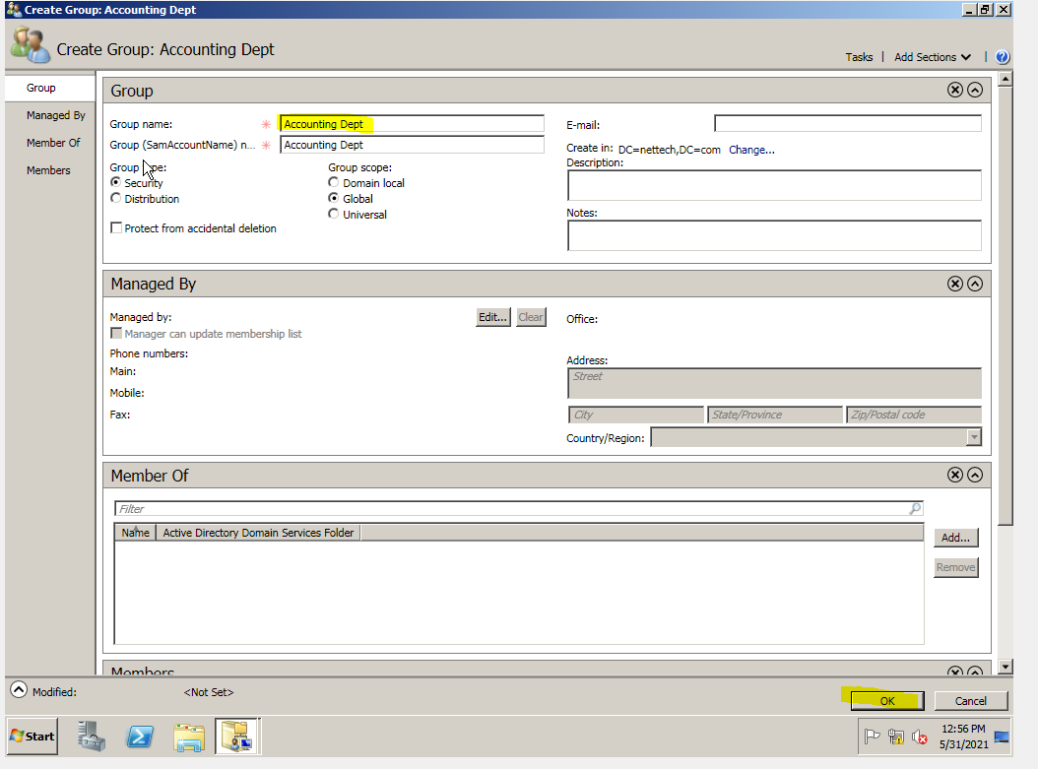

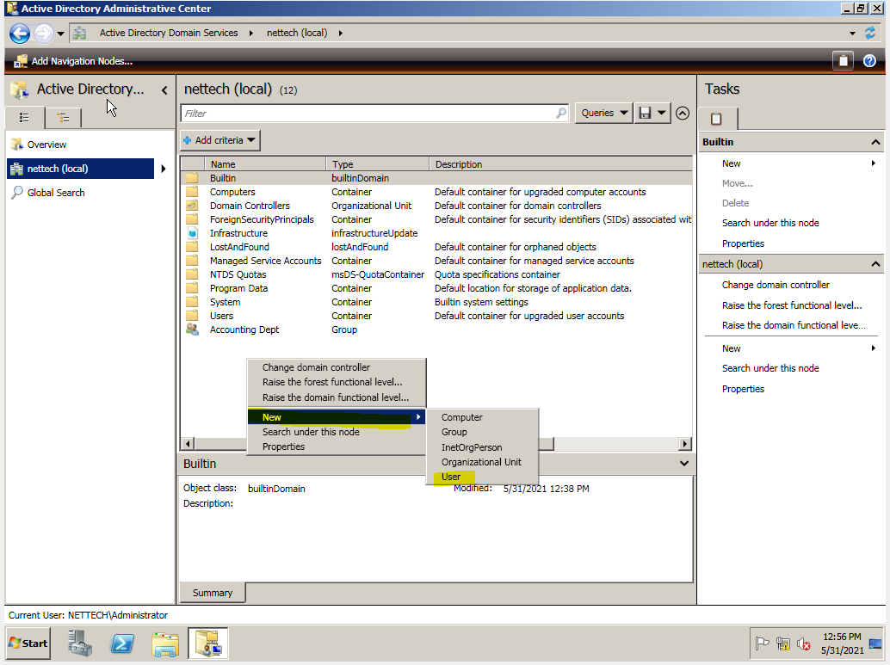

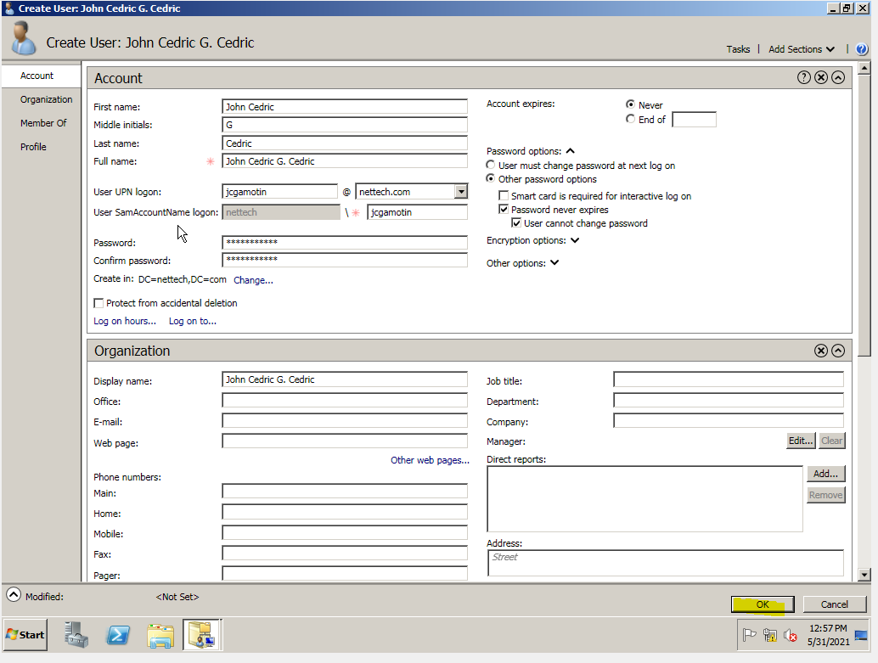

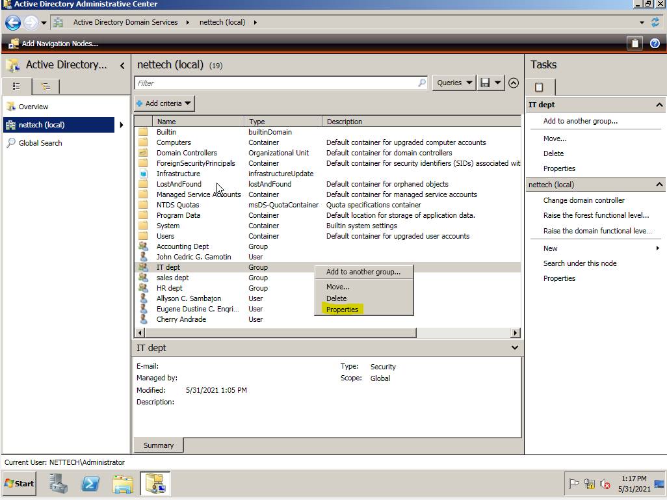

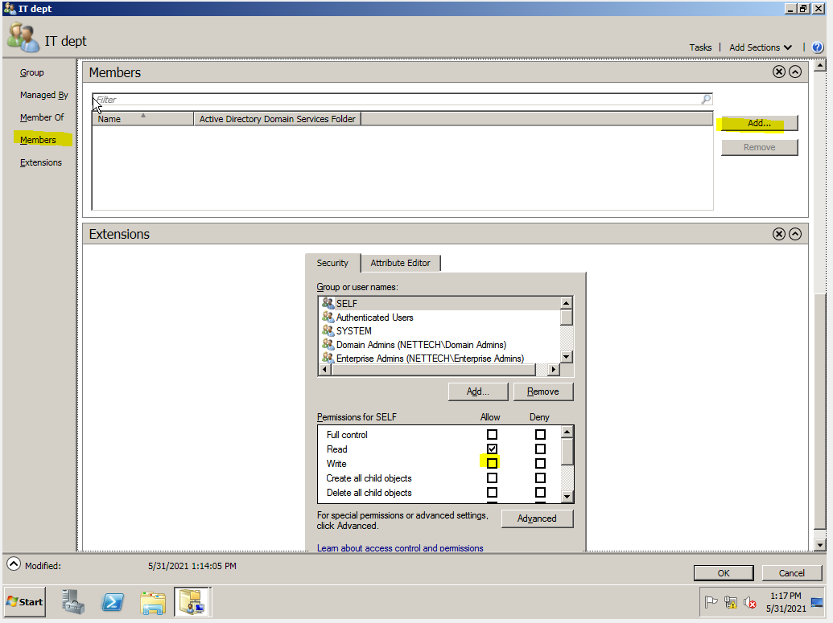

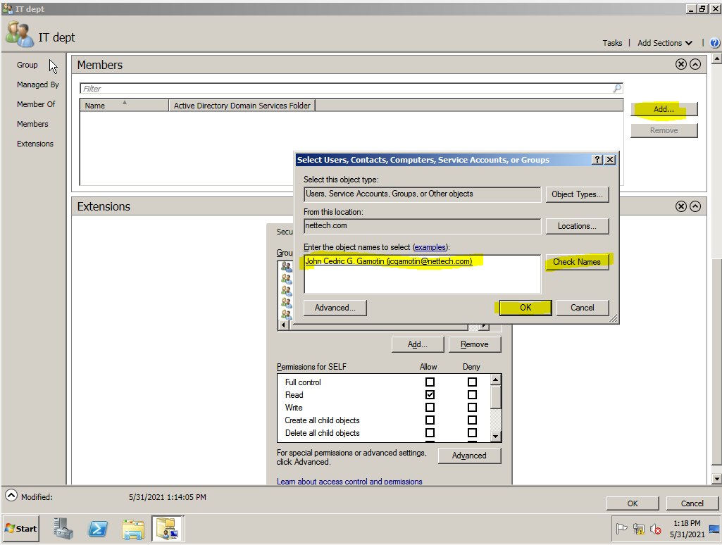

* Active Directory

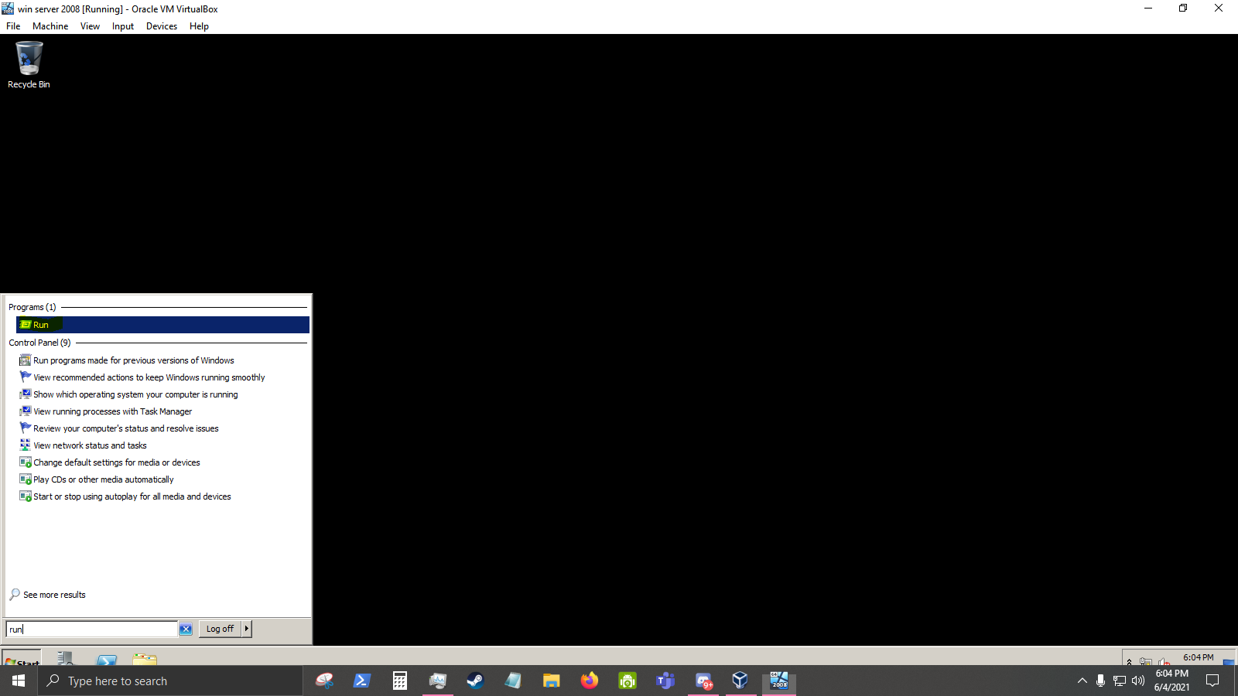

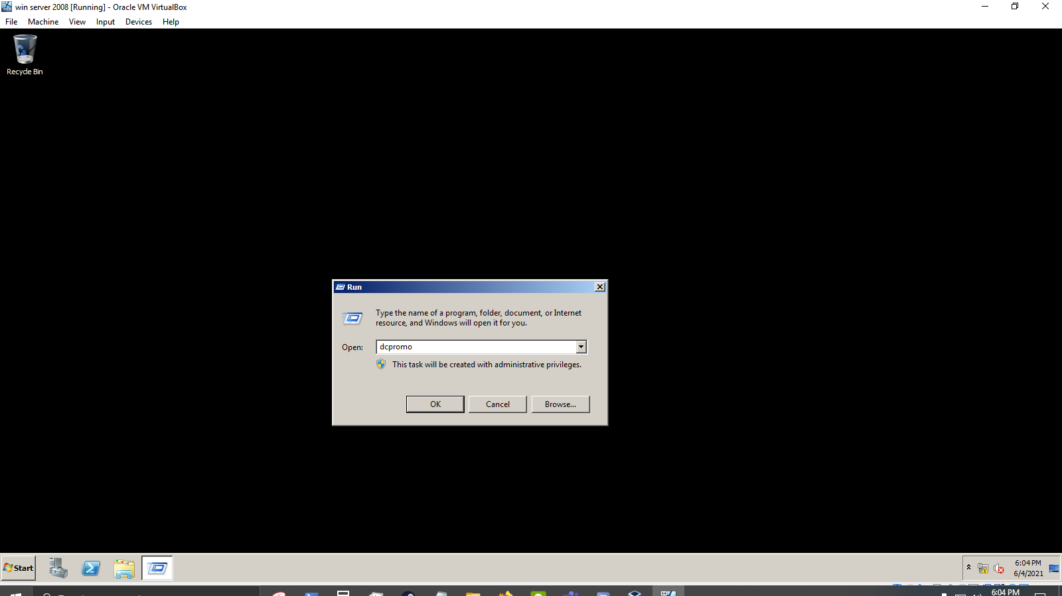

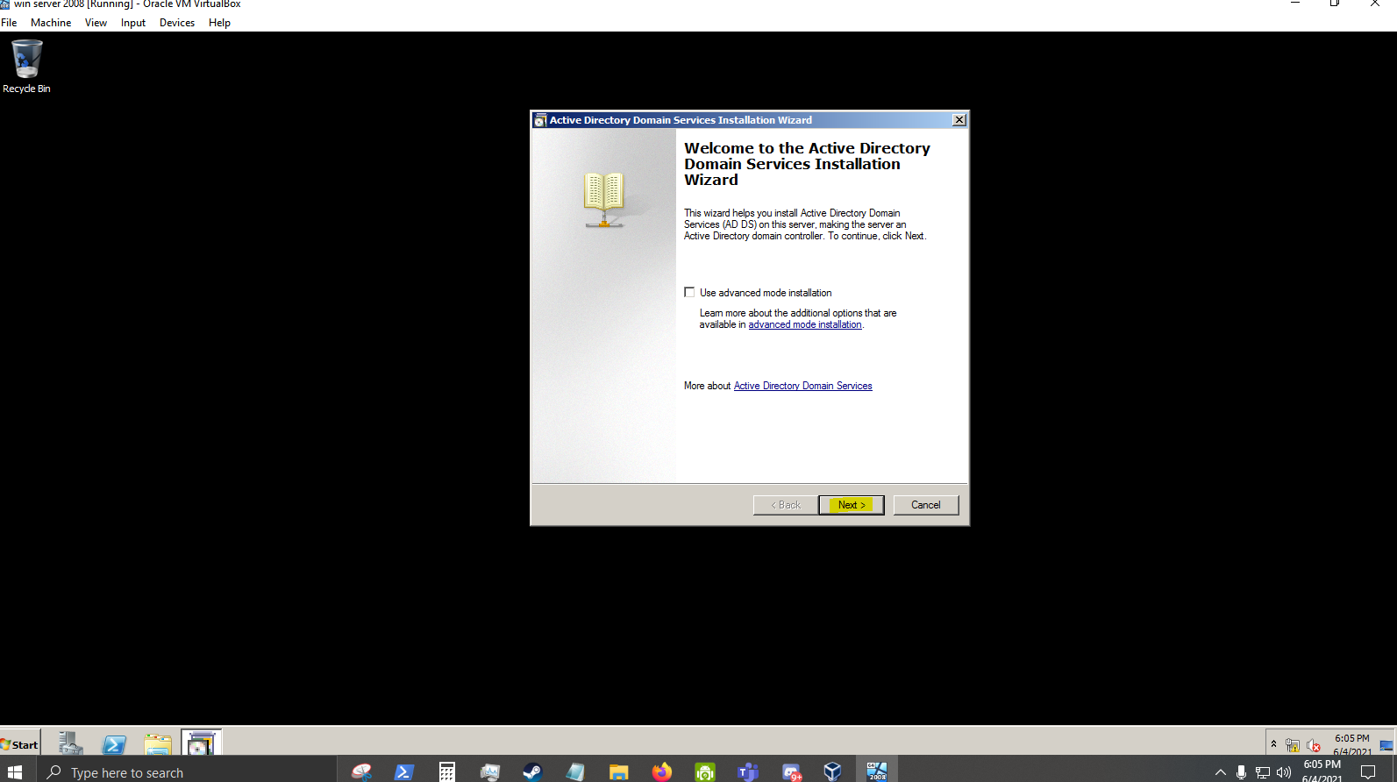

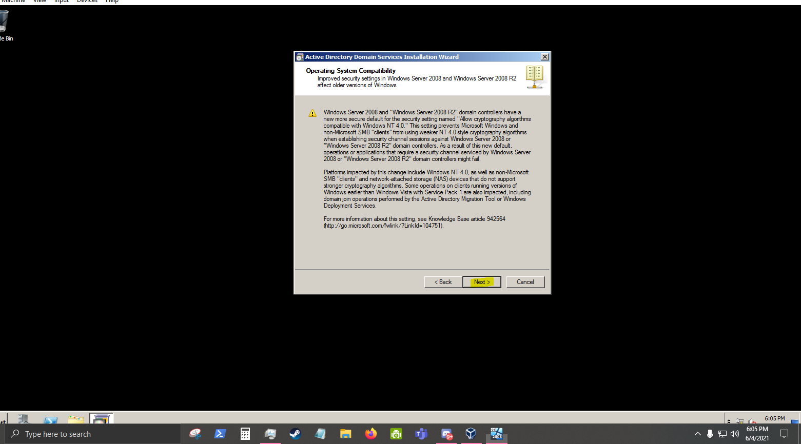

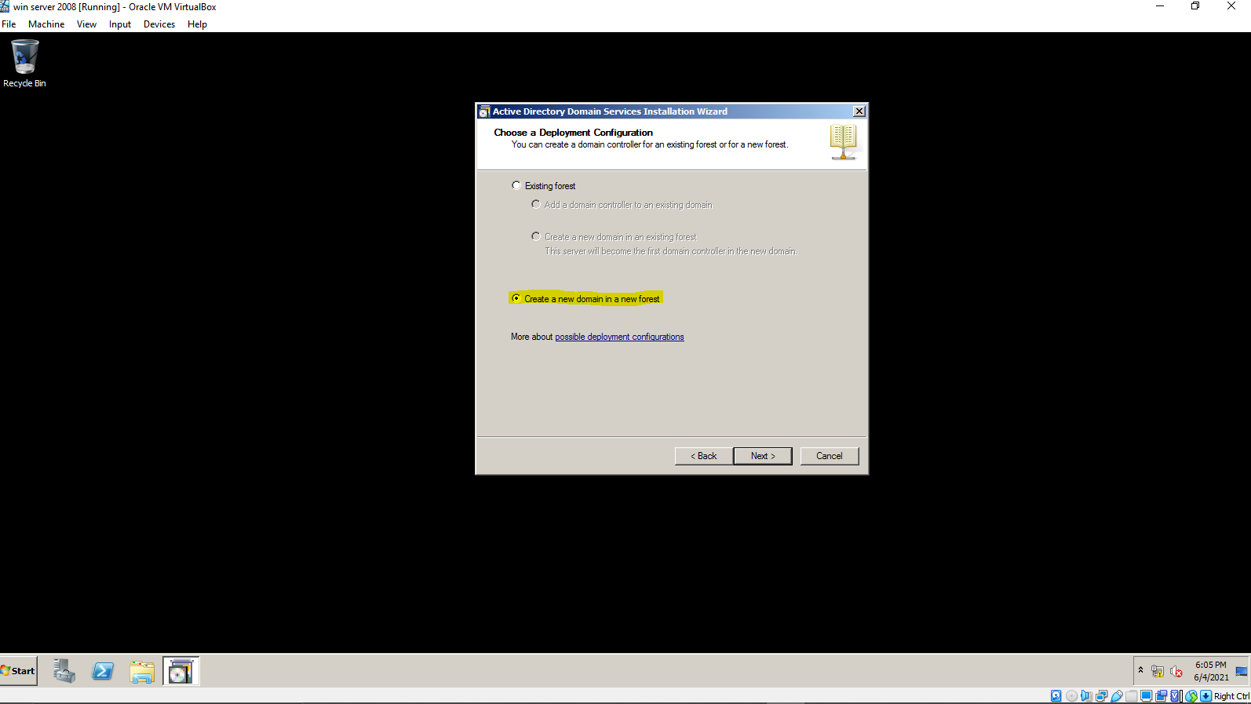

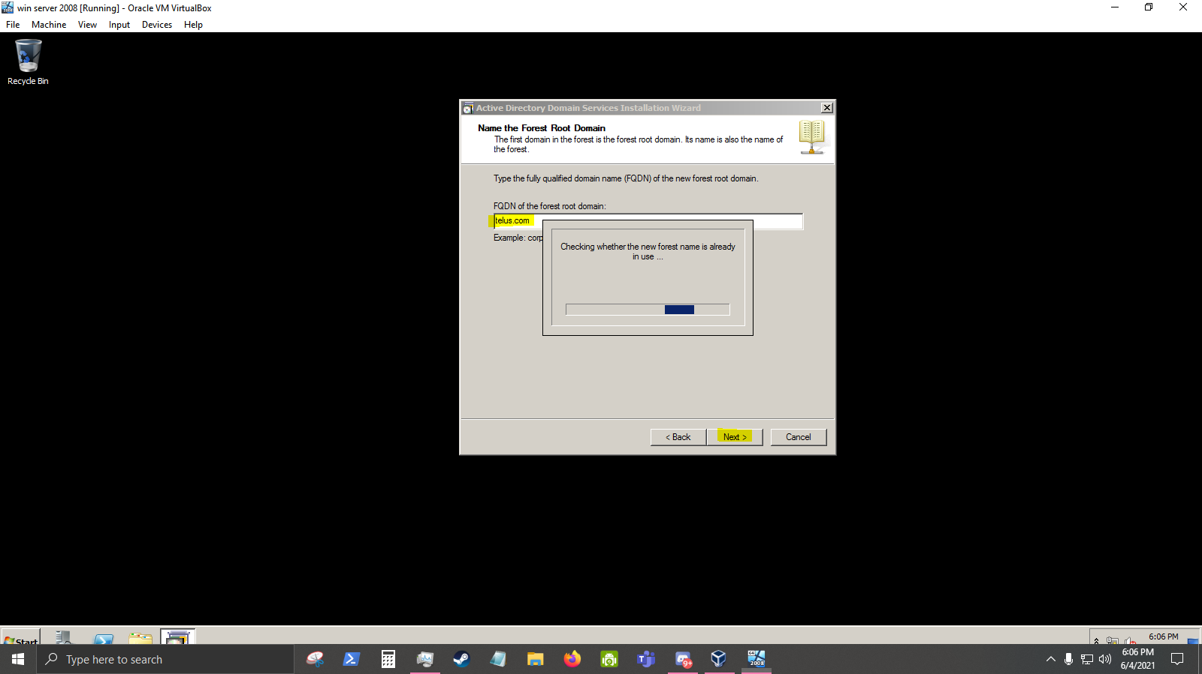

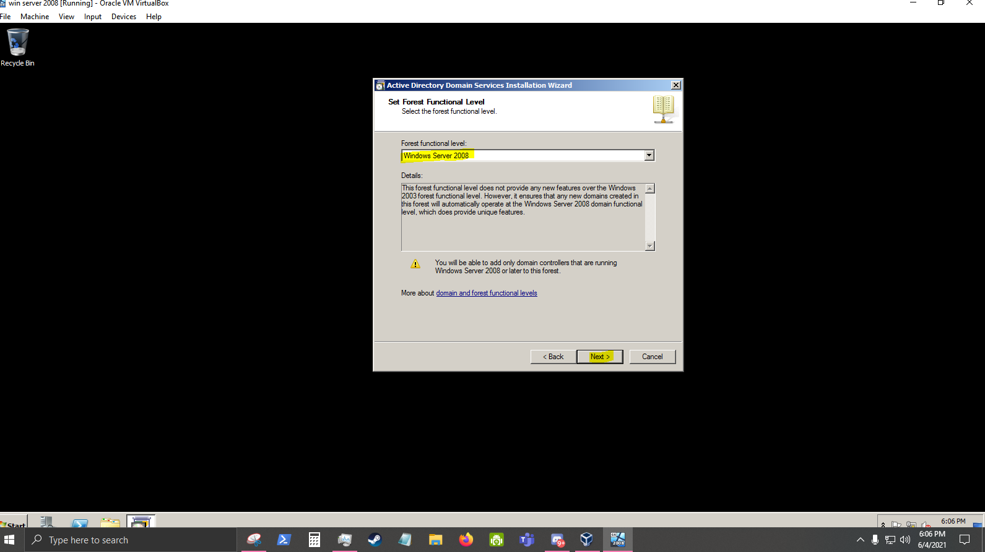

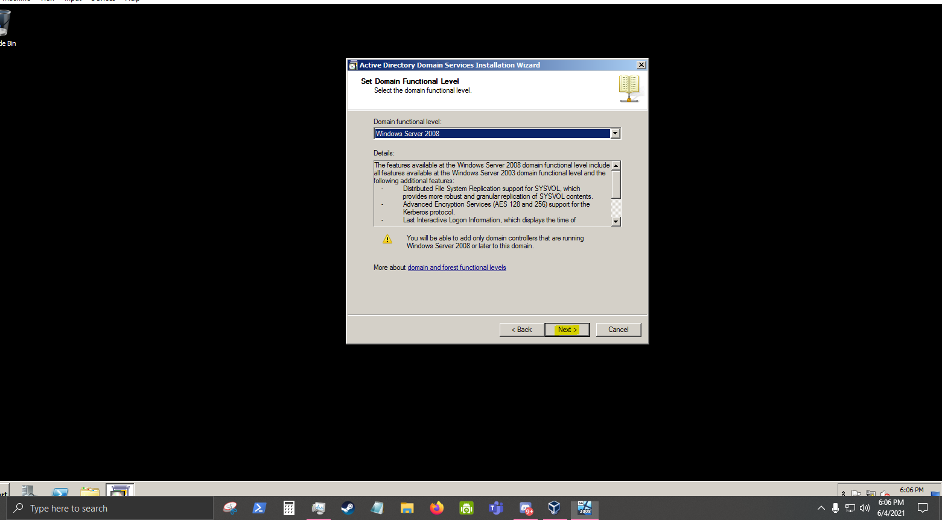

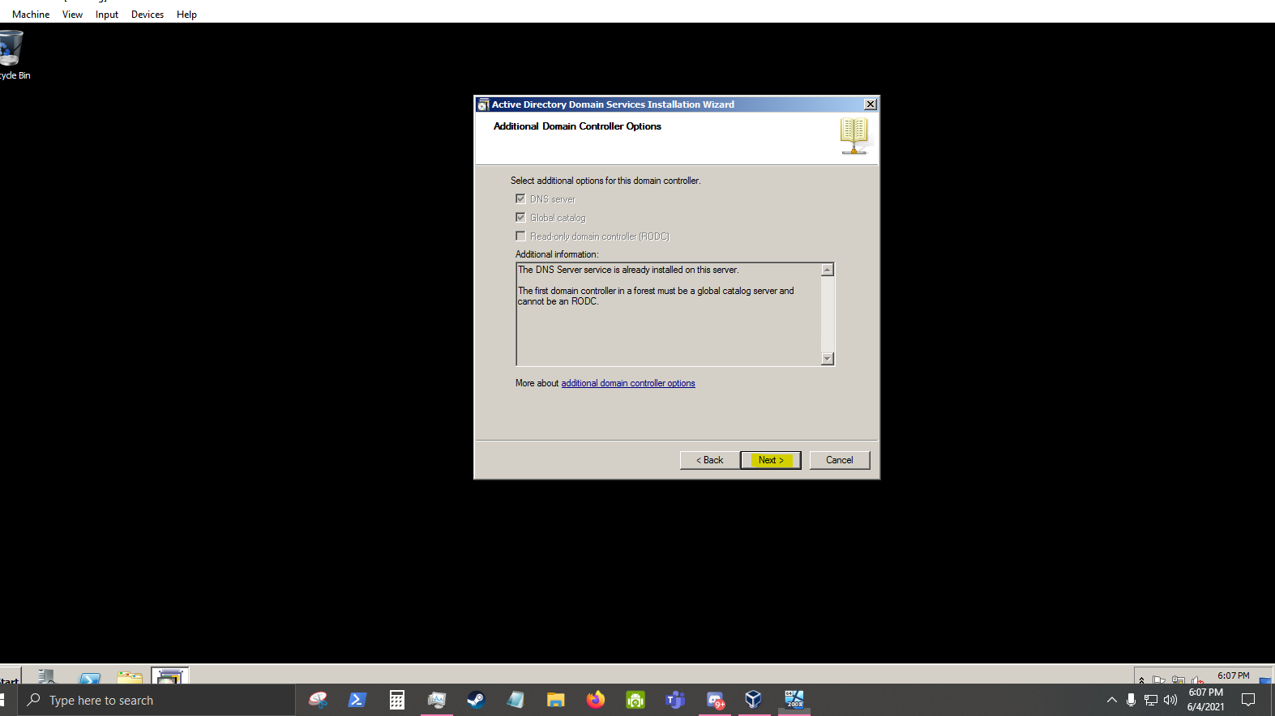

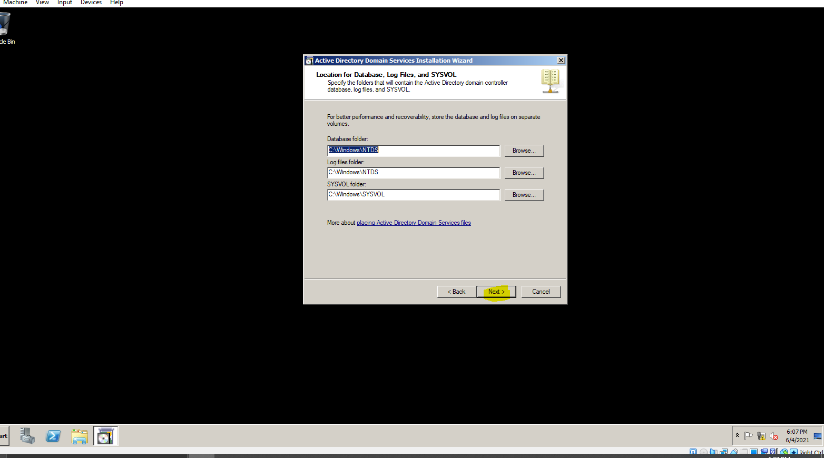

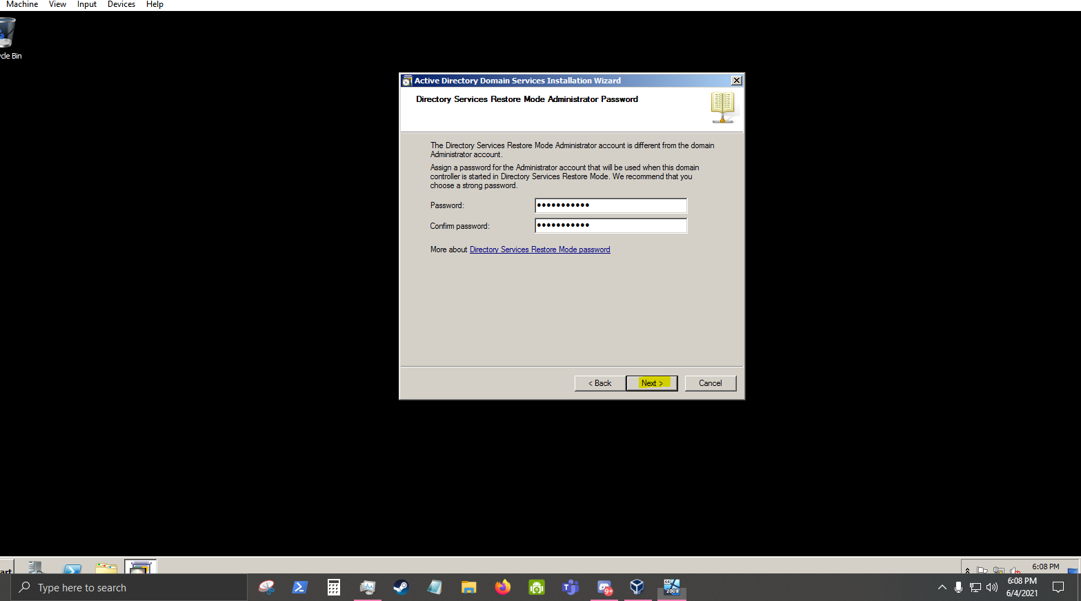

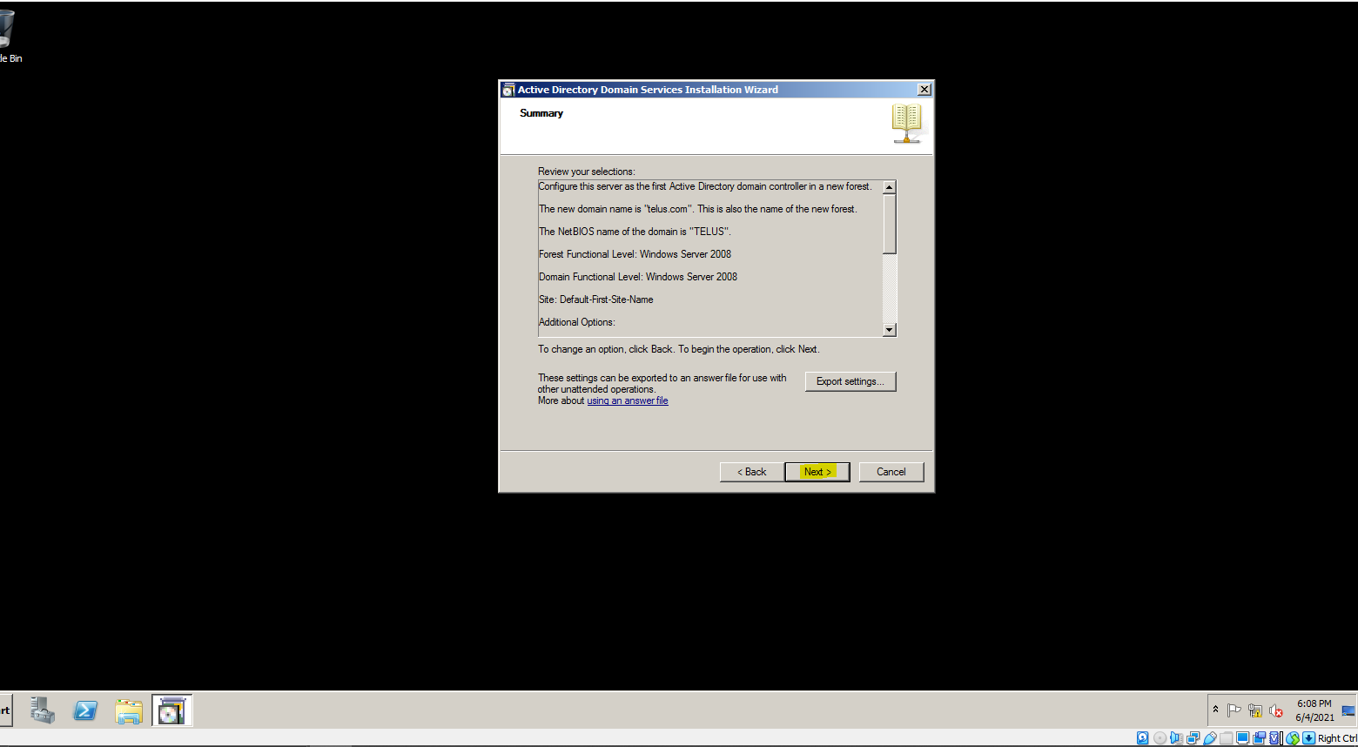

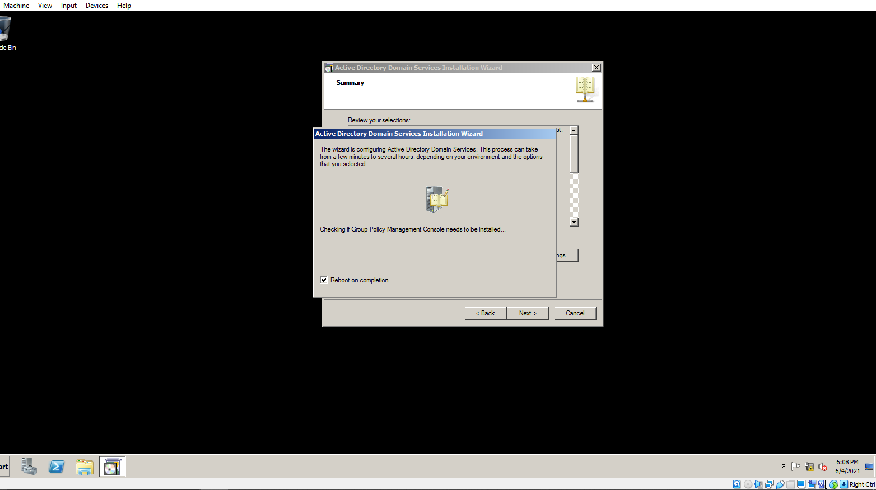

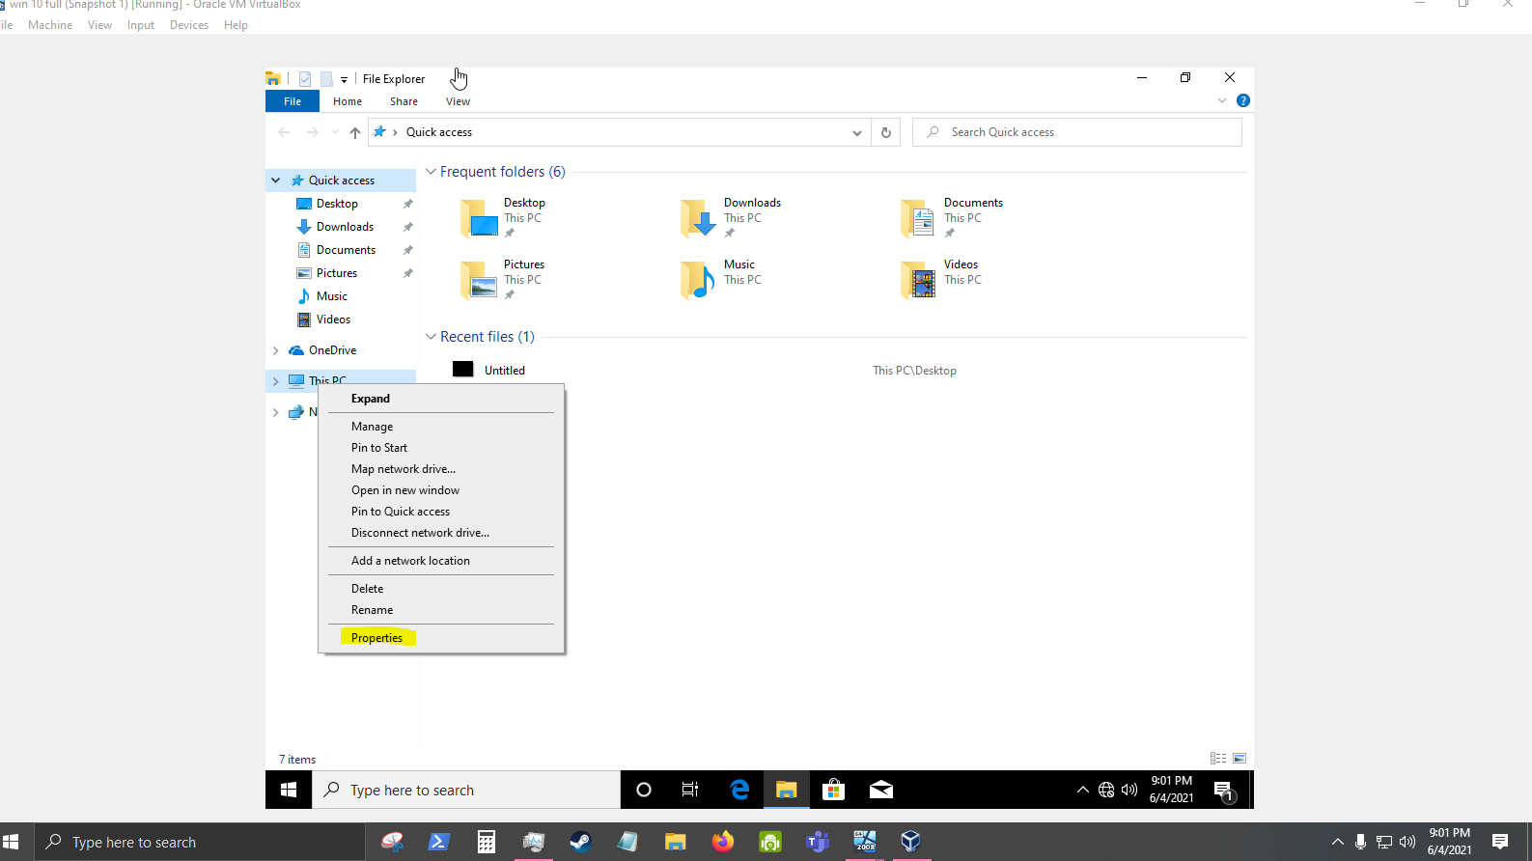

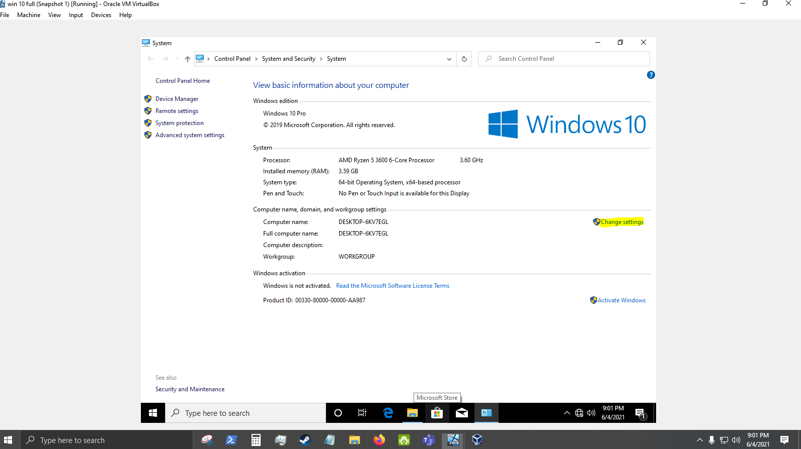

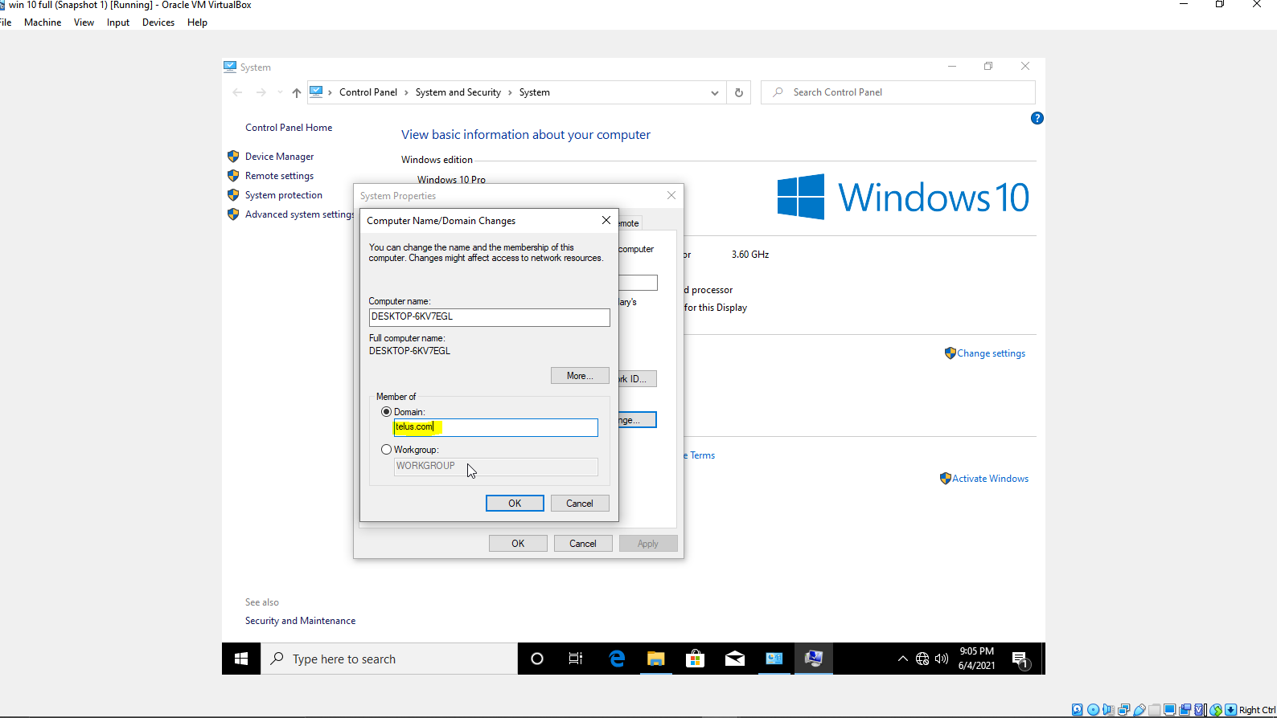

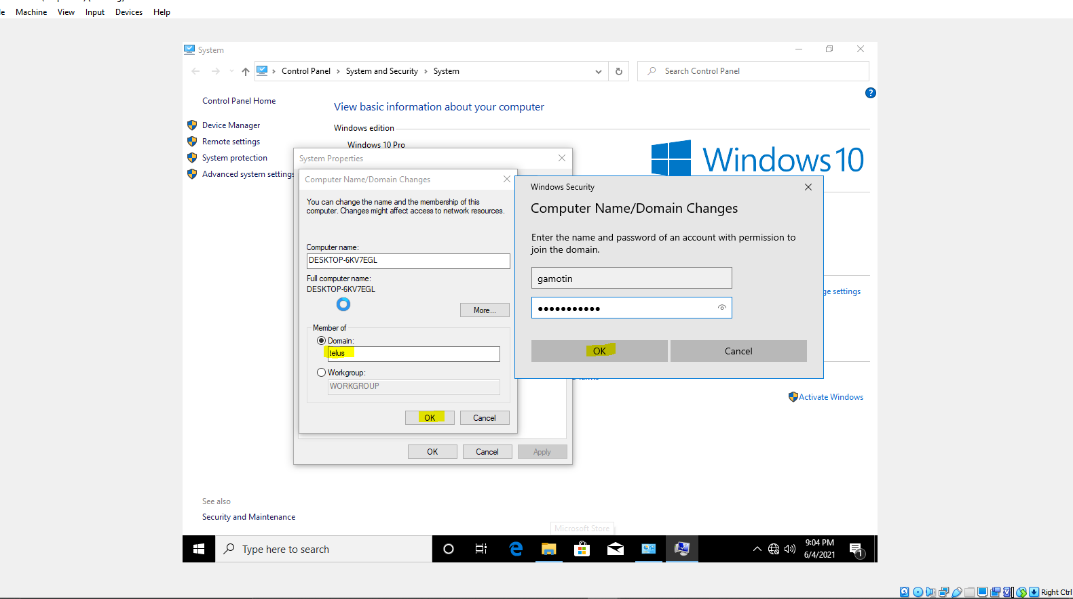

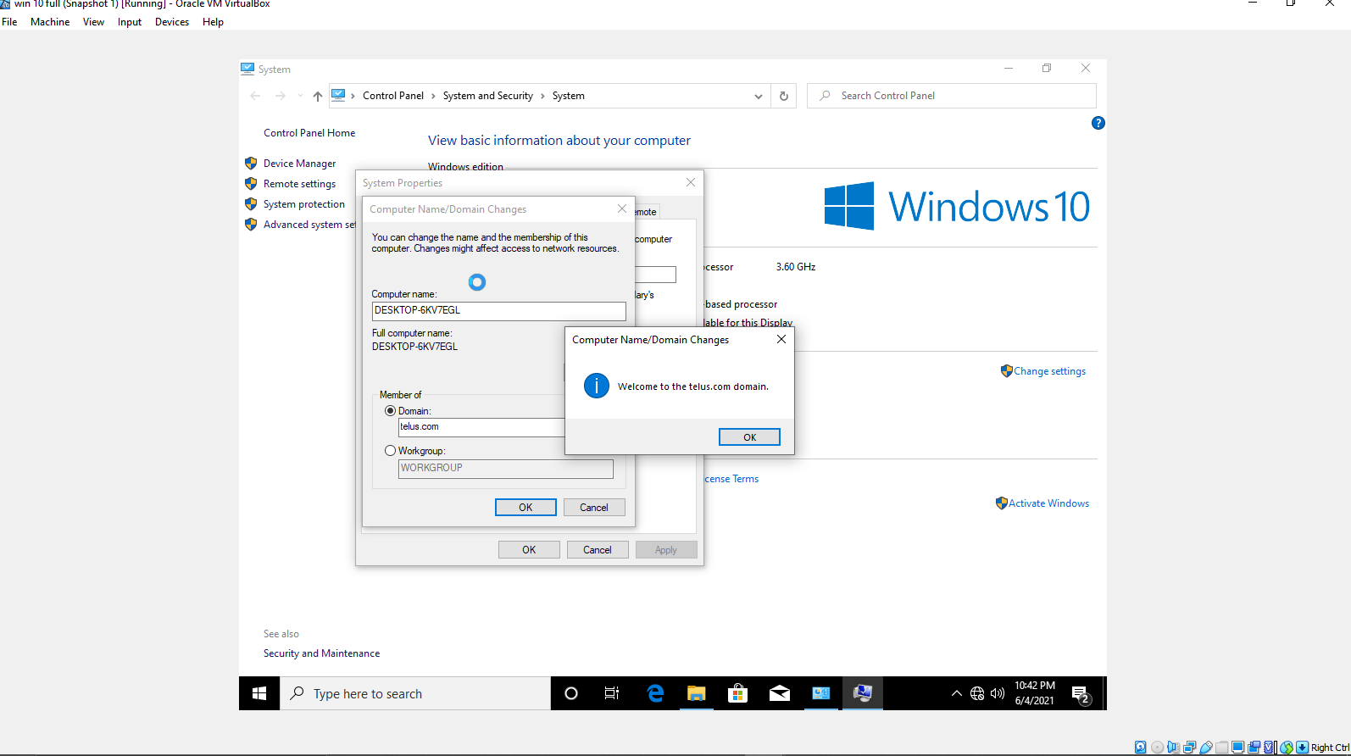

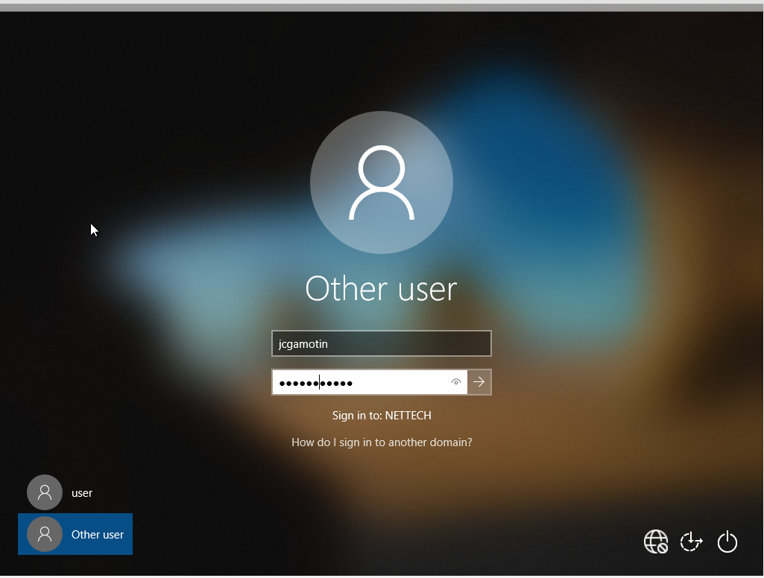

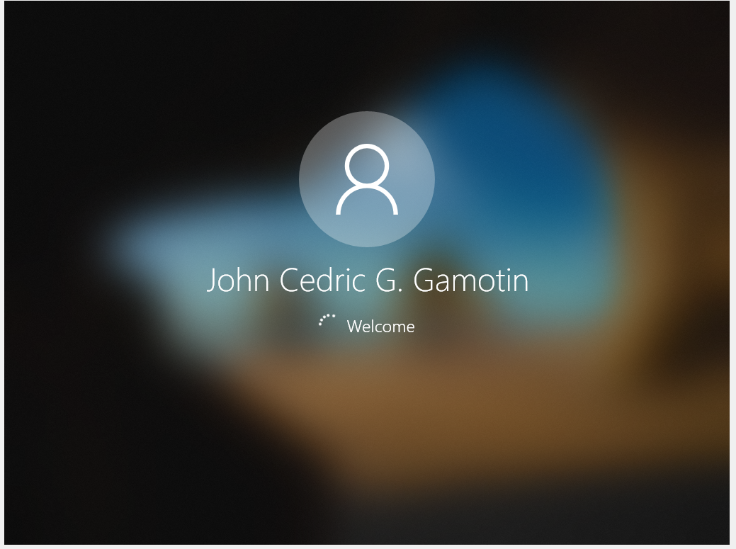

* File Server

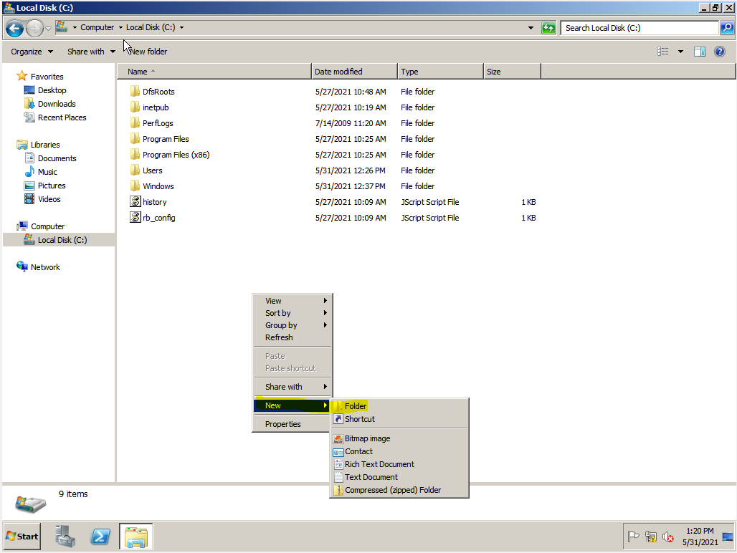

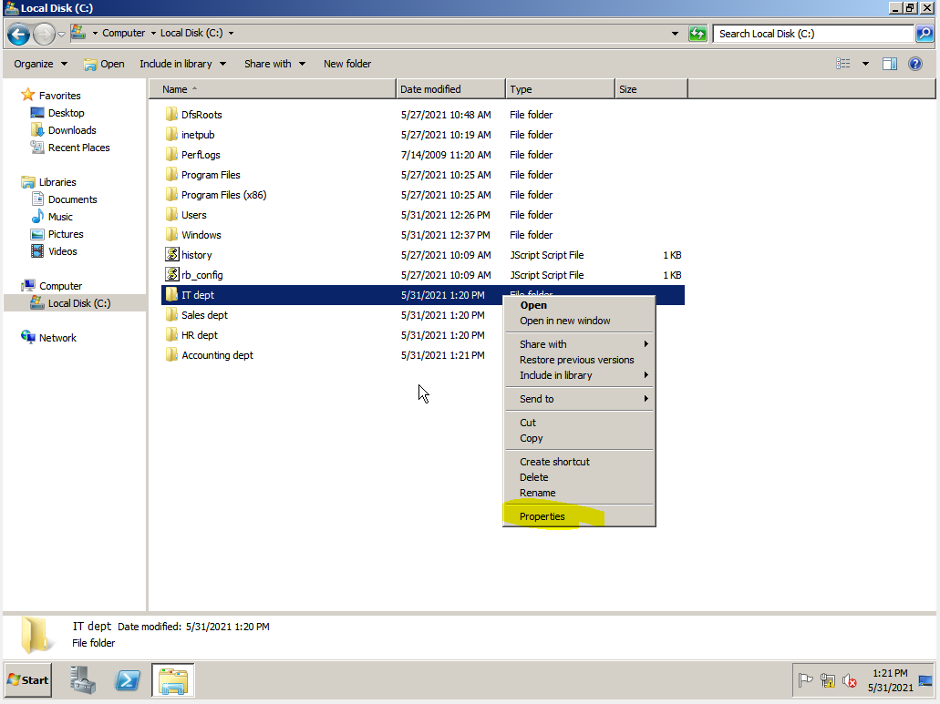

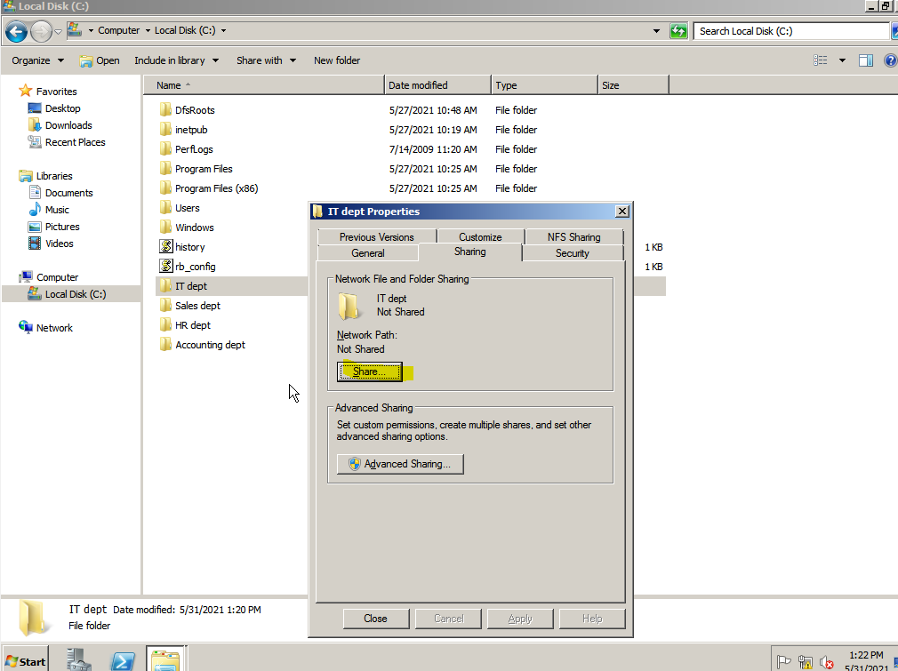

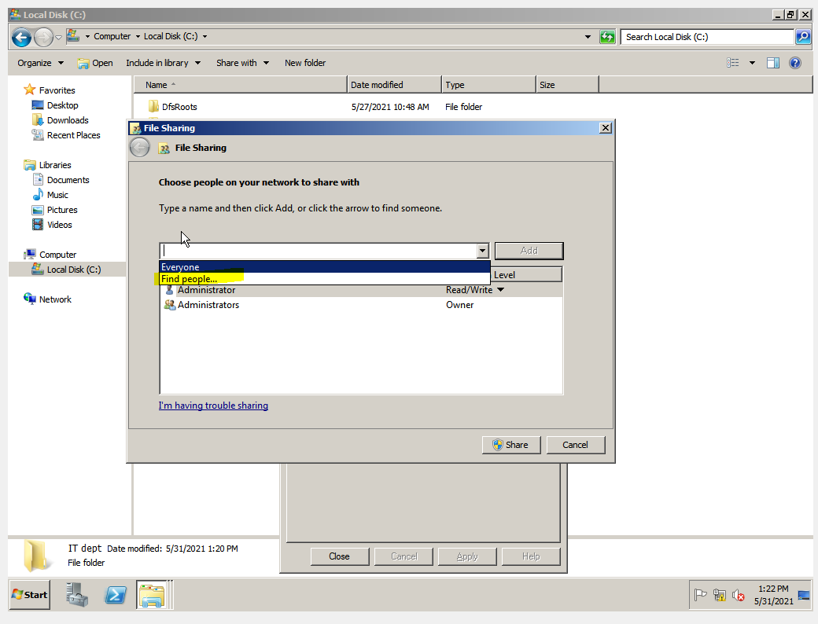

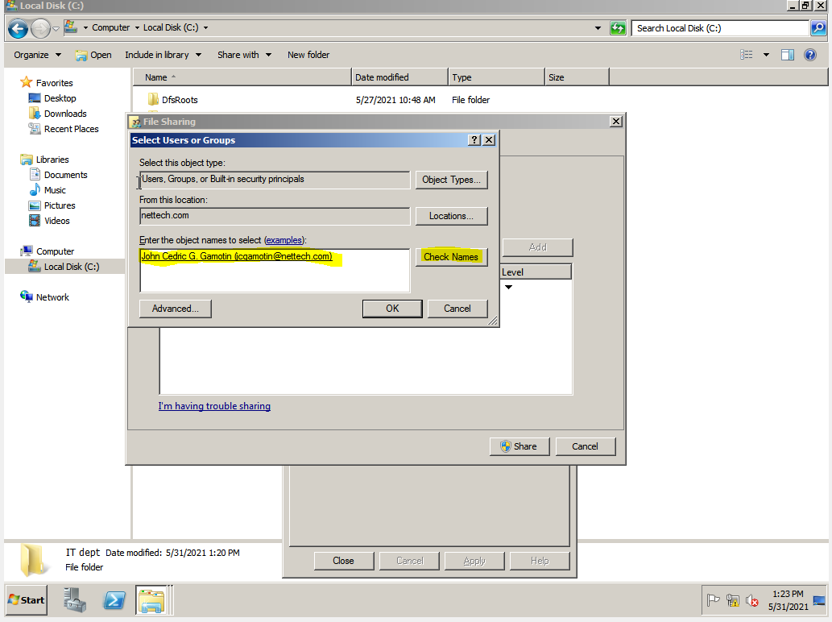

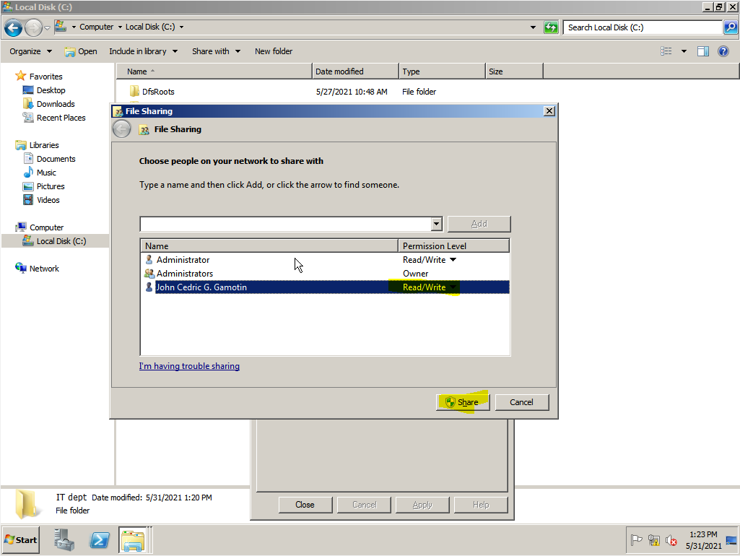

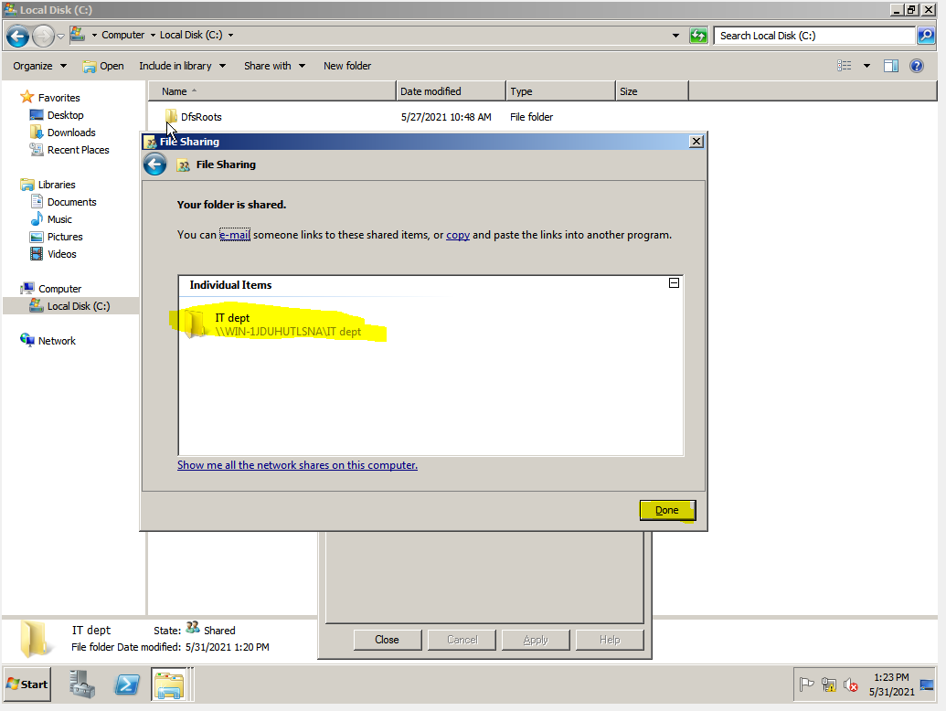

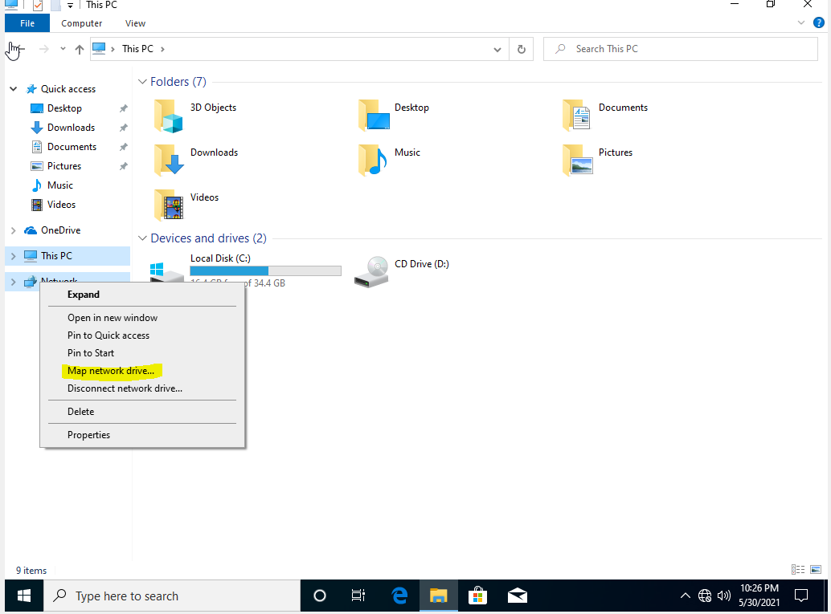

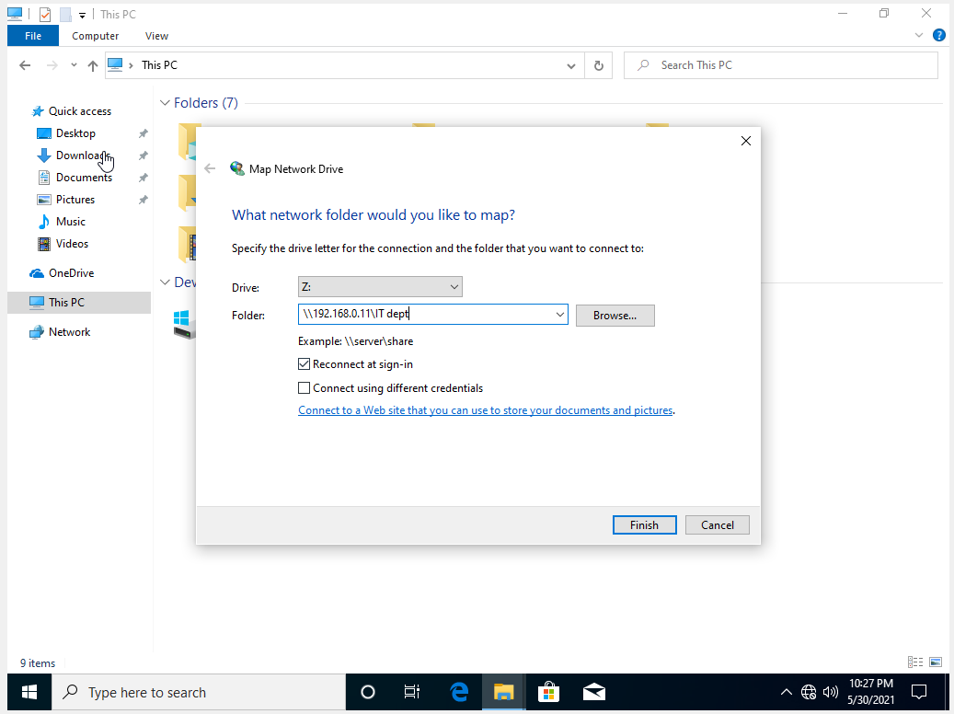

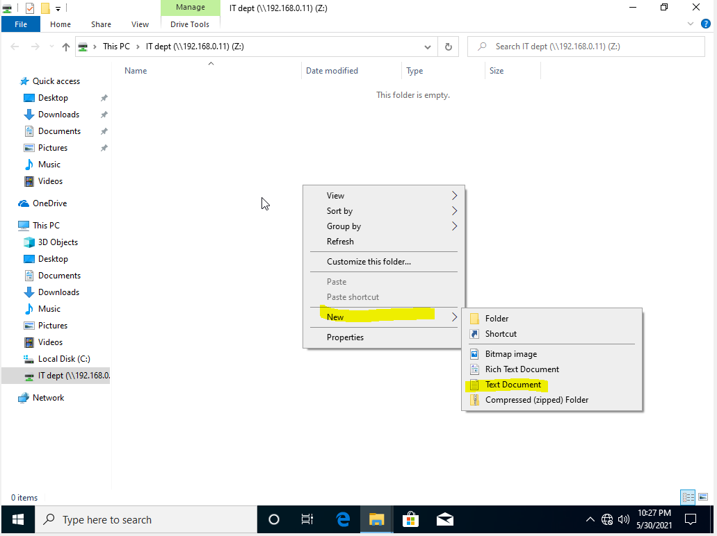

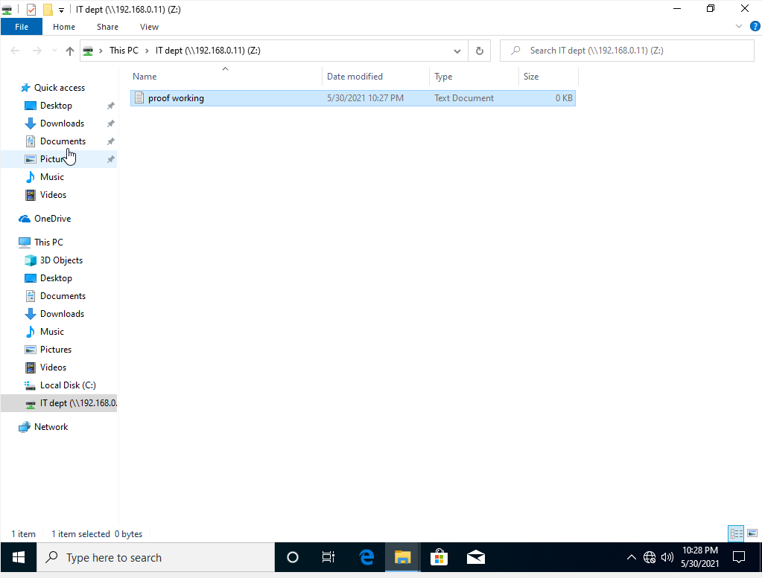

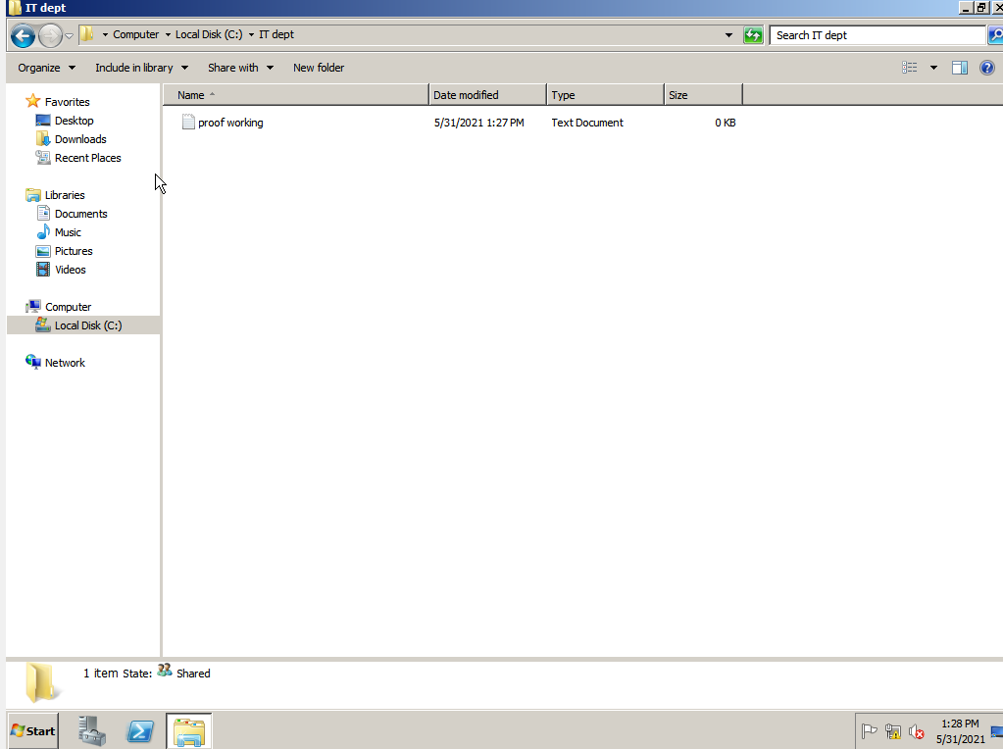

* Web Server Configuration

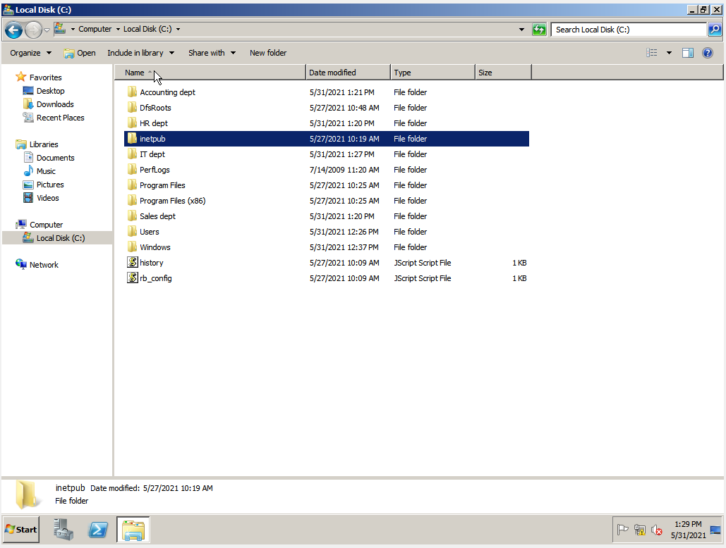

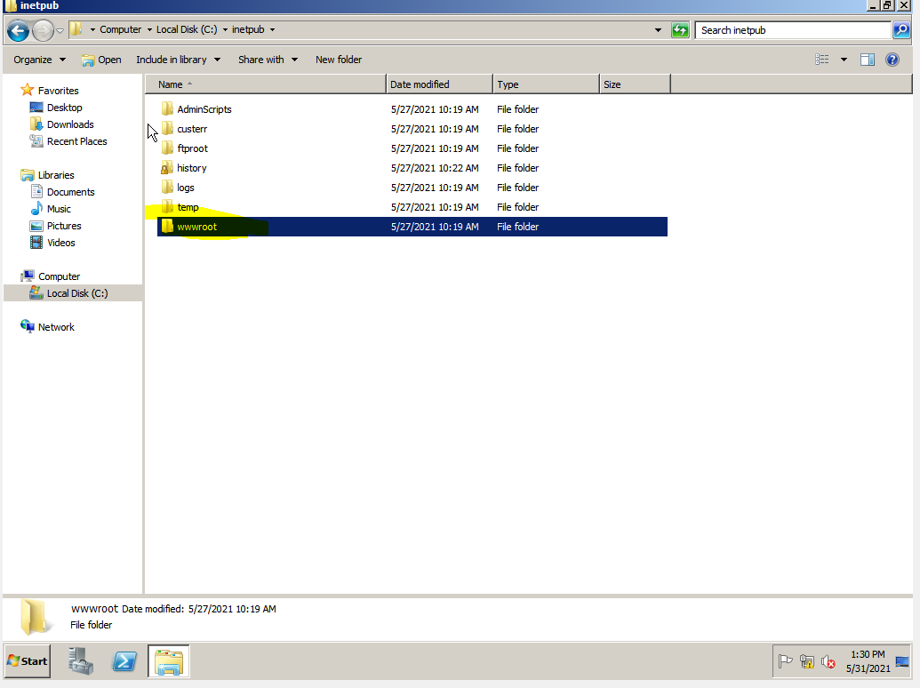

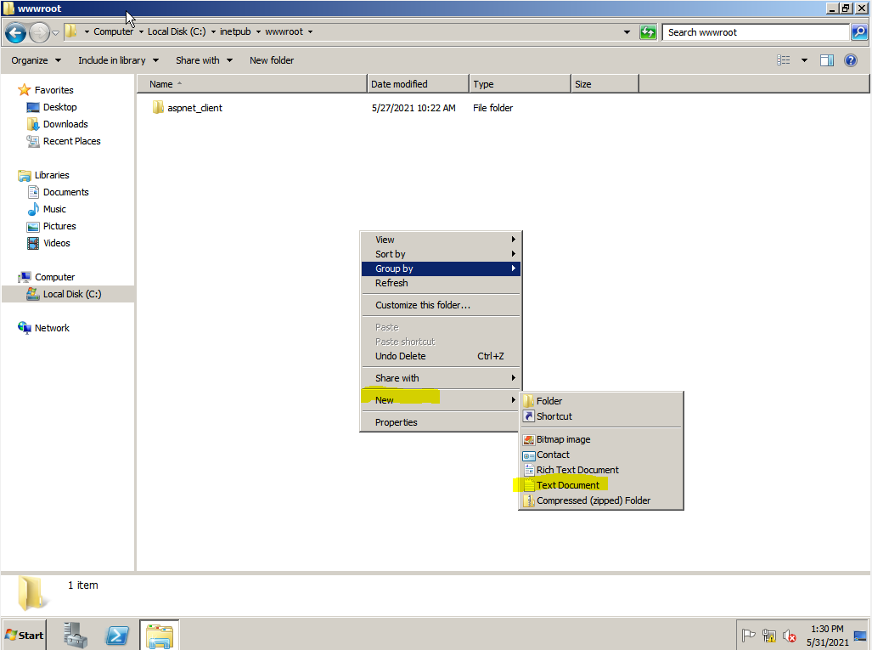

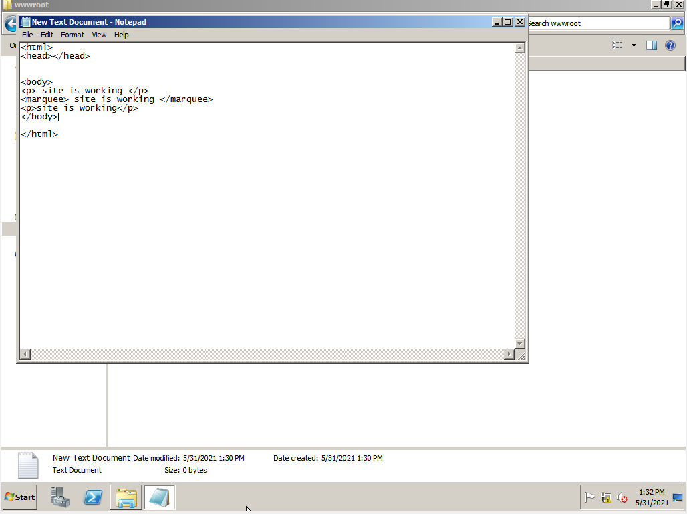

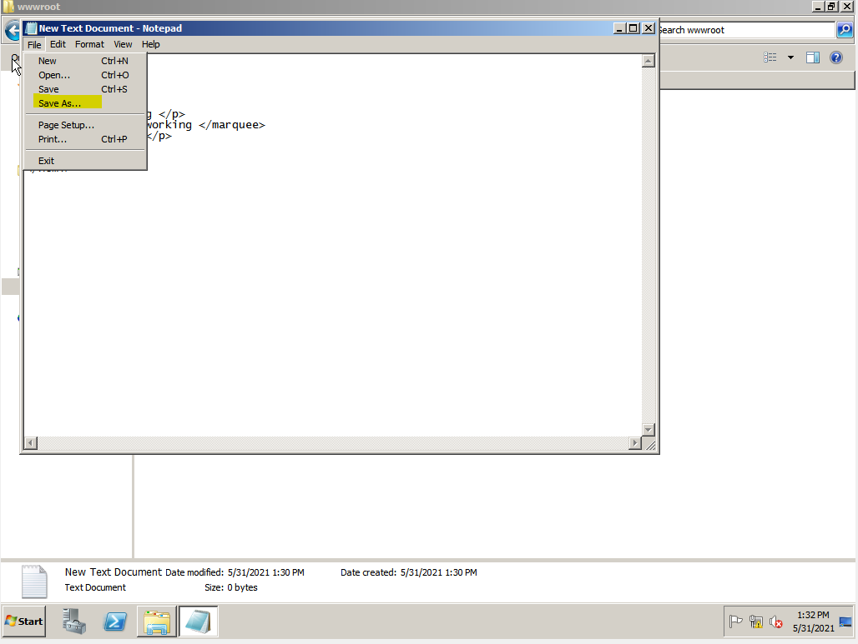

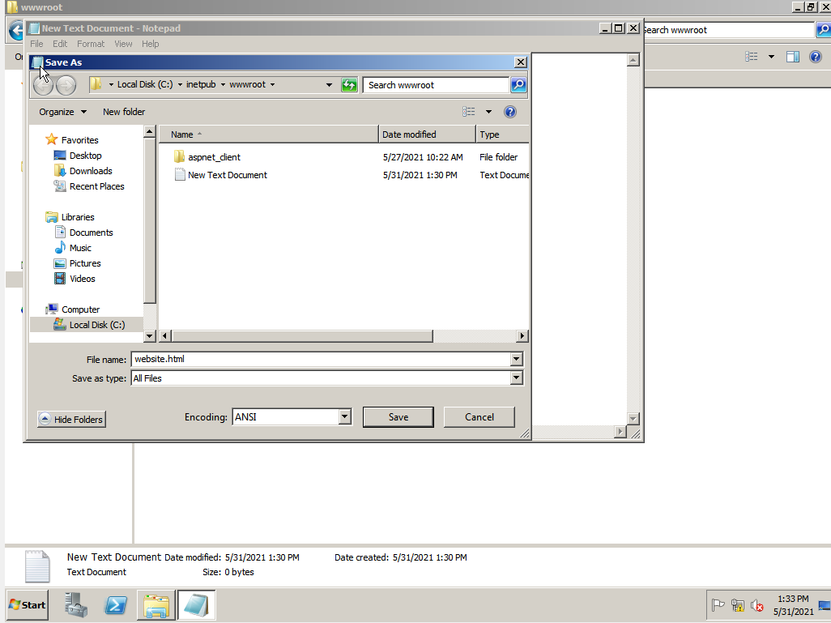

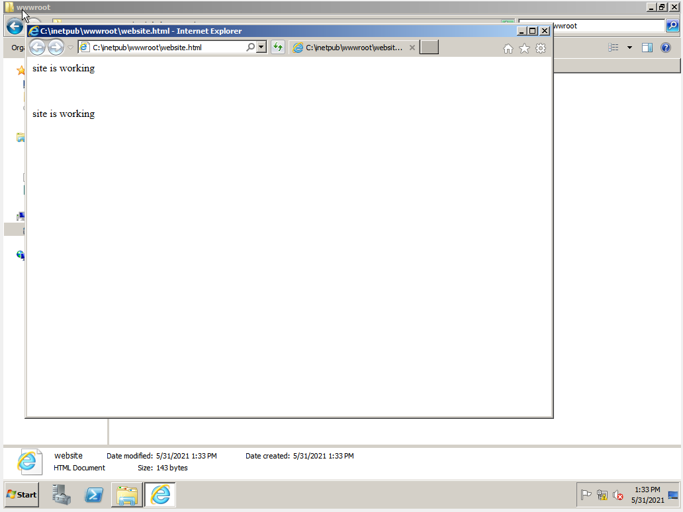

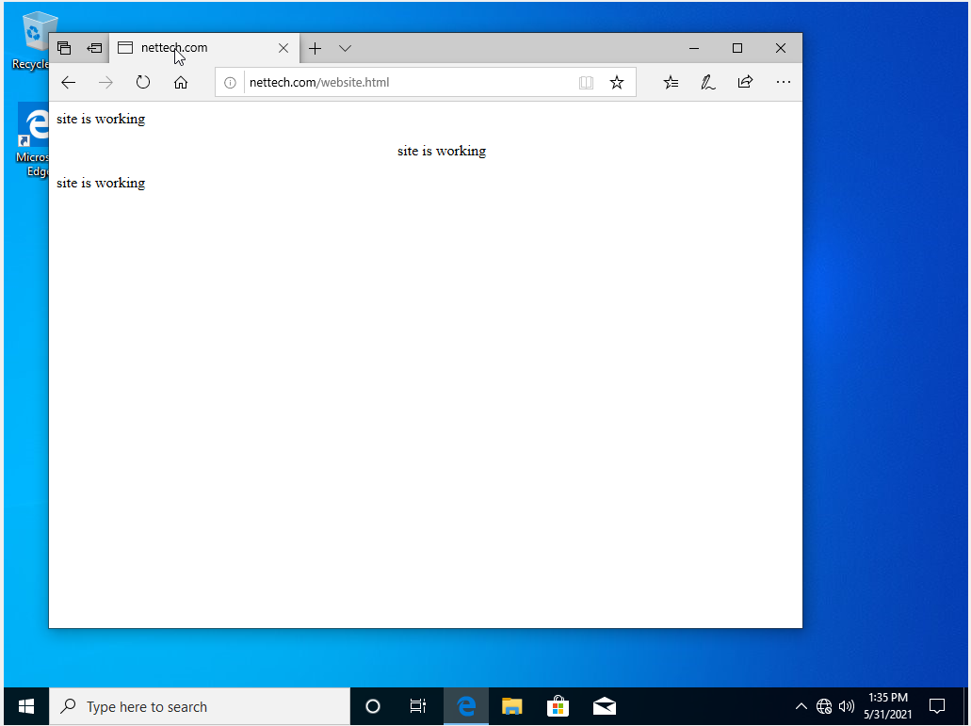

* 1. **Recommendation and Summary**

We should always have a budget set up for network system upgrades and maintenance in order to back up and enhance the system. The corporation, on the other hand, will be rapidly increasing in the future years. Devices and applications should be upgraded on a regular basis to improve performance.

As we carefully planned, Telus International has a network infrastructure to help our clients grow their business. In terms of security to be secured of their information and data. When it comes to our devices and equipment, we assure you that they are all brand new and high-quality regarding technology for our network's goods. Our network design is a hybrid structure; we have the main router where the connection all comes from. We inspect all devices to avoid a bad connection of every employee, misuse, malfunction, modification, destruction, or improper and disclosure.

* 1. **Curriculum Vitae**

